ABOUT US
HISTORY
NRI INSTITUTE OF TECHNOLOGY, popularly known as NRIIT was established in the year 2008, by MNK EDUCATIONAL SOCIETY in Visadala village, Medikondur Mandal of Guntur district by Sri.Ravindra, Chairman. NRIIT is located away from the hustle and bustle of the city life in a scenic and serene environment spread over an expansive 10.9425 acres amidst the lush greenery of mirch and cotton fields of Visadala Village just 9 kms away from Guntur, the major city of the capital region of Andhra Pradesh. The institute has set a benchmark in providing its students the very best in terms of infrastructure and faculty.
The college meticulously implements quality policy. With absolute discipline, well ventilated classrooms, multimodal teaching methodology, campus placement training, caring teachers, committed staff, proactive managing committee, vigilant security,a dedicated canteen, a fleet of buses, a mineral water plant, spacious auditorium, and outdoor grounds, power backup with 3 generators. NRIIT a unique professional college in the state of Andhra Pradesh. NRIIT is now Autonomous;affiliated to Jawaharlal Nehru Technological University Kakinada, and approved by AICTE.
The college offers 7 Under graduate(CSE,CSE-DS,ECE,AI&ML,Civil,VLSI)and 5 Post graduate programmes in engineering and management approved by AICTE. The college has a sprightly academic ambience with a strength of 2600 students pursuing various programmes.
NRIIT upholds the idea that workplace is an abode of home and the staff and the students are its members of family. The institute is a symbol of egalitarian outlook without discretions. NRIIT student activity council is organized exclusively by students with representatives from various disciplines stands for the advocacy of democracy and leadership opportunities provided by the institute. NRIIT student clubs enable all the students and staff mingle freely to express their views and share their talents and expertise. NRIIT imparts Outcome Based Education (OBE) which gives equal opportunities to teaching and learning curricular, co-curricular and extra-curricular activities. Motivational talks, spiritual discourses, academic seminars, career guidance and advice by prospective employers, educational counseling, remedial classes, intramural literary and cultural competitions, competitions in sports and games, project exhibitions, student symposiums, parades and drills, community service, campaigning for socially useful causes, participating in awareness programmes, placement drives, College day and Techno-Cultural Festivals provide NRIIT students a comprehensive and satisfying learning experience.

VISION , MISSION & QUALITY POLICY
Our Vision
- To become reputed institution of Engineering & Management programs with competitive, ethical &social responsibility
Our Mission
- IM1: Provide quality education through best teaching and learning practices of committed staff.
- IM2: Establish a continuous interaction, participation and collaboration with industry to provide solutions
- IM3: Provide the facilities that motivate/encourage faculty and students in research and development activities.
- IM4: Develop human values, professional ethics and interpersonal skills amongst the individuals.
Our Quality Policy
- To pursue standards in all endeavors with a holistic educational motive of continuous monitoring, evaluation, and improvement, aiming at the total satisfaction of the stakeholders.

PRINCIPAL
Our PRINCIPAL’S PROFILE
Dr. Dola Sanjay. S is a Professor & Principal in the Department of Electronics and Communication Engineering at NRI Institute of Technology. He is a post-doctoral researcher in Data Mining at Christian Central University, Malawi. He received his PhD in EMI/EMC from JNTUA, Anantapur, AP 2015. He has 25+ years' insightful experience as a principal, in-charge principal, and Vice Principal, All India Council for Technical Education(AICTE), Local Inspection Committee (LIC), Facts Finding Committee (FFC), National Board of Accreditation (NBA), National Assessment and Accreditation Council (NAAC). He was awarded as Bharat Ratna Dr Abdul Kalam Gold Medal Award in 2018 from Education and Research, Global Economic Progress and Research Association, Tiruvannamalai. He was also awarded Best Organizing Committee Member certification International Conference on Advanced Computing and Communication Technology in 2021. In 2024, he was recently awarded as Bheeshma Award from the Bharat Education Education Excellence Award. His research interests include RF/mm- wave/sub-mm, EMI/EMC microstrip antennas. He has published 62 publications in reputed international journals, ten national conferences, ten international conferences and 04 book chapters on EMI-EMC Analysis, Next Generation Computing Technologies on Computational Intelligence, Implementation of Fitness Certificate in Professional Colleges, Transient Analysis of Sf6 Circuit Breaker Arc Conductance Using Python and 03 Indian patents.
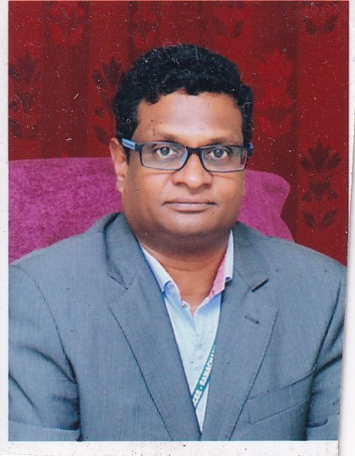
Moreover, 03 research scholars have been awarded under his guidance, and 06 will be awarded. He is the Editorial board member and technical reviewer for various International journals of repute like IRJ, IJSER, IJARIET, JETIR, and IJACT, etc.. He is an Advisory Committee for international conferences from 2018 to 2021 like ICETSTM-18, ICMPET-2019, ICSET-19, ICCCEEE–2020, ICEATE-2020 ICACCT' 21, ICAST-2021, ICASET-2021. He has been invited speaker for many conferences, workshops and faculty development programs in India as well as Abroad. Dr. Dola Sanjay S had successfully executed 02 research projects sponsored by the Entrepreneurship Development Institute of India (EDII) and the AICTE-sponsored STTP-Short Term Training Program. Currently, he has 01 ongoing research project from The Institution of Engineers (India), Technical Department, R&D Grant- in-aid Scheme, "A Smart Access Control for Restricted Buildings Using A Vehicle Number Plate Recognition System". He is a Principal Investigator to the SERB-sponsored two-day national level symposium on "Embracing the feature: AI-Powered 5G/6G Antenna design".
It is my distinct honour and privilege to introduce you to an eminent Electronics and Communication Engineering Personality, Dr Dola Sanjay S serves as the Professor & Principal at NRI Institute of Technology, where his leadership has been instrumental in shaping the academic landscape. With a robust academic background, he pursued post-doctoral research in Data Mining at Christian Central University, Malawi, following the completion of his PhD in EMI/EMC from JNTUA, Anantapur, in 2015.
Contact Details:
E-mail: nriit.guntur@gmail.com
Mobile:9701037149

VICE PRINCIPAL
Our VICE PRINCIPAL’S MESSAGE
You must be the change you wish to see in the world”– Mahatma Gandhi
With an immense pleasure, I welcome you to be a part of our Institution.
Technical education is the backbone of every nation and is the stepping stone for a country to cut the niche of its kind in a developed nation. The tremendous recent changes in the current scenario preset both challenges and opportunities in the engineering education. Our Institution has set specific objectives and planned activities for achieving excellence in all spheres of technical domains. The facilities and resources offered by Institution will enhance the skill sets of the students and will eventually translate their ideas into products or services for the effective growth of our Nation.
It gives me immense pleasure to welcome all the students of under-graduate and post-graduate courses to NRI INSTITUTEOF THCHNOLOGY (NRIIT). In fact, it gives me immense pride that our students receive the best quality education in our Premises. This has become a reality by imparting very high standards of teaching & learning practices and researches. A strong focus is laid on high order skills, fostering positive relationships among all.
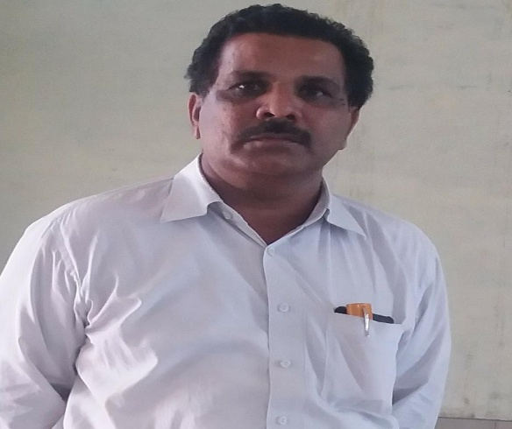
Excellence, in both academic and co-curricular aspects is an integral value of education that we offer to our students. We inculcate social values and social awareness through a variety of academic, co-curricular and extracurricular activities. We strongly encourage students to participate in these activities and showcase their talents.
NRIIT ensures that the students prove themselves to be not only well-qualified engineers but also very responsible and ideal citizen of our country. It is a real pleasure and a moment of pride for us to hear from our alumni who are now working with multi-national companies in a vast array of jobs and situations around the world. Some of them are pursuing their higher studies at leading universities and colleges as well.
I wish you a very happy and academically highly rewarding student life in KSRCT and hope that your good deeds will enhance the pride and prestige of our Institution.
Best of luck for all your future endeavours!.
Yours fraternally,
Prof.K.SRIHARI RAO., M.E., Ph.D.
Vice Principal

MANAGEMENT
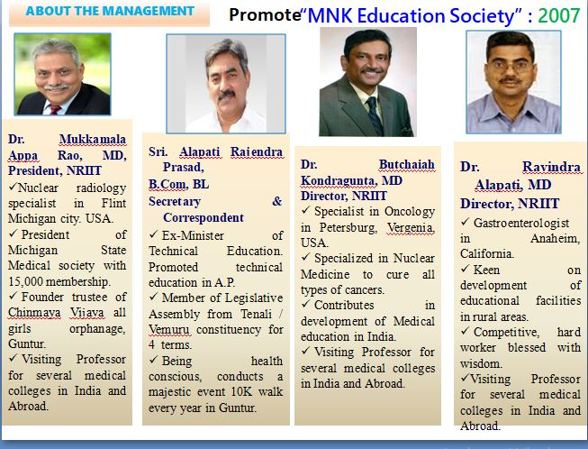

AFFILIATIONS & ACCREDITATIONS
Established in the year 2008-09.
Accredited With NAAC A+ Grade.
Granted Autonomous Status by UGC and JNTUK.
Affiliated to JNTUK Kakinada.
Recognized by University Grant Commission (UGC) under Section 2(f) of the UGC Act,1956.
ISO 9001 - 2008 certified institution.
Click below files for University & AICTE Affiliations
Click here for AICTE JNTUK APPROVELS.pdf
Click here for NRI - KP - Affilaition Order JNTUK.pdf

GOVERNING BODY
The Governing Body of the College
S.No. | Name | Designation
1 | Dr.Mukkamala Apparao | President
2 | Sri. Alapati Rajendra Prasad | Secretary & Correspondent
3 | Sri.N.Srinivasa Rao | Member
4 | Sri.M.Srinivasa Rao | Member
5 | Smt.Alapati Madhavi | Member
6 | Prof.V.Vara Prasad | JNTUK Nominee
7 | Sri.J.Murali Mohan | Educationist
8 | Sri.K.Subrahmanyam | Industrialist
9 | Dr.K.Srihari Rao | Member
10 | Mrs K.Sujatha | Member
11 | Dr.K.Srinivasu | Principal & Member Secretary

CODE OF CONDUCT
A) CODE OF CONDUCT FOR PRINCIPAL, TEACHERS, NON TEACHING STAFF AND STUDENTS
PRINCIPAL
1. The Principal should always be honest, fair, objective, supportive, protective, and law abiding.
2. Should implement new ideas and plans to execute the college's vision and mission.
3. Should we promote democratic values on campus and make the campus a liberatory and emancipatory space? 4. Listen to staff and student’s ideas and set a supportive tone.
5. Ensure that the staff and students are aware of the rules, policies, and procedures laid down by the college.
6. Should be just and fair in interactions with staff and students.
7. Should establish effective channels of communication and ensure ease of access to staff and students.
TEACHERS
I. Teachers should:
1. Adhere to a responsible pattern of conduct and demeanor expected of them by the academic community.
2. Seek professional growth through study and research.
3. Contribute to knowledge building through meaningful participation and sharing of ideas at professional meetings, seminars, conferences, etc.
4. Maintain active membership of professional associations and organizations, and build networks and alliances within academia.
5. Perform their duties in the form of teaching, tutorial, practical, and seminar work and carry out all responsibilities assigned by the institution in matters relating to admission, invigilation, and assessment.
6. Participate in extension, co-curricular, and extra-curricular activities, including community service.
II. TEACHERS AND THE STUDENTS
1. Teachers should accord dignity and respect to all students across gender, caste, class, religious, and ethnic locations.
2. Respect students’ rights to freely express their opinions.
3. Be fair and impartial to all students, regardless of religion, caste, political, economic, or social status.
4. Celebrate diversity within classrooms, not just in terms of social locations but also in terms of capabilities, and strive to meet their individual needs.
5. Encourage students to improve their academic performance and also contribute to the community.
6. Inculcate among students a spirit of critical inquiry and the constitutional ideals of democracy, patriotism, and peace;
7. Students must not be humiliated, belittled, objectified, or body shamed.
8. Be mindful of the fact that each student is different and has different boundaries and sensitivities.
9. Treat students with kindness and compassion.
III. TEACHERS AND COLLEAGUES
1. Conduct themselves with absolute dignity and decorum in their dealings with senior and junior colleagues and students.
2. Speak respectfully of other teachers and render assistance for professional betterment;
3. Be mindful of prejudices along caste, class, gender, ability, and ethnic lines and do not allow them to interfere in their discharge of duties.
IV TEACHERS AND NON-TEACHING STAFF:
1. Teachers should treat the non-teaching staff as colleagues and equal partners.
2. Teachers should help in the functioning of committees and cells comprising both teachers and non-teaching staff.
V. TEACHERS AND SOCIETY
1. Teachers should:
1. Recognise that education is a public service and therefore should keep the public informed of the educational programmes that are being provided;
2. Be aware of social problems and take part in such activities as would be conducive to the progress of society and the country as a whole;
3. Perform the duties of citizenship, participate in community activities, and shoulder the responsibilities of public offices;
4. Refrain from taking part in, subscribing to, or assisting in any way in activities that tend to promote feelings of hatred or enmity among different communities, religions, or linguistic groups.
2. NON-TEACHING STAFF
1. All institute employees must perform their duties efficiently and diligently in accordance with the college's rules and regulations.
2. All staff members should display the highest possible standards of professional behaviour.
3. Punctuality and discipline are of utmost importance.
4. Every staff member shall maintain the appropriate levels of confidentiality with respect to student and staff records and other sensitive matters.
5. Every staff member should be respectful and dignified in interactions with students, teachers, and colleagues.
6. Staff members must refrain from any form of harassment or discrimination based on existing legislative norms relating to gender, sexuality, age, and marital status.
GENDER POLICY
1. The institution recognises gender as a student’s social identity that can be male, female, transgender, or non-binary. Given the systemic nature of gender discrimination, our approach to gender issues has been an integrated and holistic one, focusing on challenging gender stereotypes and subverting commonsense perceptions of culturally prescribed gender roles. We believe in integrating and embedding gender concerns into every activity on campus, including teaching, research, and administration. Every constituency on campus, that is, students, teaching, and non-teaching staff, is sensitized on gender issues on a regular basis through workshops, interactive sessions, and a short-term certificate course. The Gender Issues Cell exists as a mandated body as per Section 3.2 (15) of the UGC Guidelines (Prevention, Prohibition, and Redressal of Sexual Harassment of Women Employees and Students in Higher Educational Institutions) Regulations, 2015. The Gender Issues Cell (GIC) works in close association with the Internal Committee, which addresses all complaints of sexual harassment within the Institute as per Section 4 of the UGC Guidelines (Prevention, Prohibition, and Redressal of Sexual Harassment of Women Employees and Students in Higher Educational Institutions) Regulations, 2015.
Objectives
• To promote a nuanced understanding of gender as a social location and how it intersects with other marginal locations of caste, class, disability, and ethnicity
• To ensure equitable access and use of resources, sustain spaces for conversations around gender and sexual identities through regular gender audits and sensitization programs.
• to support a zero-tolerance policy against all forms of sexual harassment.
• Recognize discriminatory behaviour toward people in gender marginalised positions, such as cis-women, transgender people, or people with non-normative sexualities and expressions. • To strengthen institutional mechanisms that redress incidents of gender-based discrimination
• Train and sensitise students who can champion gender awareness through workshops and other activities.
• To support advocacy on gender sensitization and establish collaborations and linkages with women’s rights and trans advocacy groups.
• To establish a Women’s Studies and Research Center.
C) RESEARCH POLICY
• Research helps to create new avenues in knowledge, promotes critical thinking and innovation, and enhances the teaching and learning experience. The Research Policy of NRI Institute of Technology (NRIIT) facilitates interdisciplinary dialogue and research across disciplines, building cultures of teaching and research that recognise different aspects of being a teacher, researcher, and scholar. Recognizing the need for transformative research, a "Research Committee" has been constituted to encourage action-oriented and collaborative research that touches people’s lives in significant ways and creates a just social order. A robust and dynamic research culture exists across all departments, which conduct activities to develop and promote the scientific temperament and research aptitude of all scholars.
Objectives
1. To provide a conducive and rigorous research environment in college
2. To enrich the teaching and learning process through the empirical experiences of both students and faculty.
3. To encourage faculty members to publish research papers in journals of repute and to undertake various research projects of social, scientific, and academic importance.
4. To organise seminars, conferences, and workshops on research methodology, academic writing and publication, research ethics, etc.
5. To identify and share information about different research and funding opportunities announced by various academic, research, industry, or government organisations like UGC, DBT, DST, BIRAC, ICSSR, and so on.
6. To promote collaborations with international and national institutions of higher learning and to promote research-based linkages with industry
7. To create awareness about patents and intellectual property rights and motivate researchers to apply for patents.
8. To encourage more teachers to apply for recognition as research guides and for departments to apply for recognition as research centers.
9. To encourage faculty to undertake consultative research projects.
10. To ensure quality, integrity, and ethics in research, we strictly prohibit plagiarism at all levels and provide online tools to facilitate its monitoring.
D) THE POLICY AND THE PROCEDURE FOR MAINTAINING AND UTILIZING PHYSICAL ACADEMIC AND THE SUPPORT FACILITIES
These policy guidelines aim for equitable allocation and efficient utilisation of available facilities and infrastructure. This will result in a quality learning and working environment for students, faculty, and staff. This policy also provides a framework for the optimal use of physical assets as well as a regular review of the infrastructural needs of the college. Maintenance of infrastructure, equipment, and other facilities is either carried out at the institutional level or on an AMC basis. The college allocates a budget at the beginning of the academic year for all infrastructural requirements.
Objectives
1. Establish standard operating procedures for the use of physical and academic facilities.
2. Optimise the utilisation and maintenance of college facilities.
3. to periodically review the needs of infrastructure and plan for the future.
This policy applies only to the use of those facilities located on campus.
Utilization and Maintenance of Common Physical Facilities Utilization: 1. The college has open space on the ground floor that is typically used for common college programmes such as the celebration of Independence Day, Republic Day, or any other open gathering as needed. On other days, this facility is available for the purpose of parking staff vehicles.
2. The use of common facilities like seminar halls, conference rooms, and an auditorium is allotted for the programmes of the college by the registrar of the college on the basis of availability.
3. Sports facilities can be used with the permission of the Sports Director of the college and on the basis of allotted time.
Maintenance: 1. The admin manager, being the maintenance head, prepares the routine and specific maintenance schedule for all physical infrastructure and allocates duties to the respective staff.
2. The maintenance schedules are executed with the support of both internal and external agencies.
3. The college has appointed a person to look after the facilities like the seminar hall and the auditorium. This staff brings to the attention of the admin manager any maintenance that has to be done. These requirements are then put before the principal for approval.
4. On the basis of the type of work and budget, either the principal or management takes care of the allotment of work.
5. This standard operating procedure for maintenance is followed at all times. Policies of Academic and Support Facilities
Utilization and Maintenance of Class Rooms: Classrooms are used for regular lectures and are assigned based on the timetable and student population.
1. Non-teaching staff is responsible for the cleanliness and maintenance of the classrooms.
2. An infrastructure committee has been appointed to supervise the maintenance of the equipment and infrastructure of the college.
3. All infrastructure-related complaints are communicated to the Infrastructure Committee.
Utilization and Maintenance of Laboratories (Dry and Wet): 1. Laboratories are allotted for practical sessions based on a timetable given by the college.
2. Standard Operational Procedures for handling various chemicals, equipment, and instruments are to be strictly followed.
3. The stock register is maintained and updated regularly.
4. Stock verification and inspection have to be carried out by the departments at the end of the academic year.
5. The disposal of old and obsolete equipment, chemicals, and instruments is standard procedure.
6. Safety training for support staff is conducted periodically.
7. The maintenance of computer laboratories is taken care of by the laboratory in charge. System administrators have been appointed to take care of the repair and maintenance of all computers and servers.
8. Annual Maintenance Contracts (AMC) are made for various equipment and software, e.g., photocopier machines and internet facilities.
Utilization and Maintenance of Library: 1. At the end of each year, the librarian notifies all departments and requests that they keep the required number of books on hand for the following academic year.
2. The library can procure books on demand from faculty and students. After getting approval from the heads of departments, the book list with price is submitted to the principal for further action. After getting budget approval, books are purchased for the library.
3. The first-year students are instructed to procure an identity card, which also enables access to the library.
4. A student can borrow three books and one magazine at a time for a period of one week. They can renew the book for another week if there is no reservation for that particular book. If they fail to return the book on time, a nominal fine is charged.
5. Students can borrow books from the reference section for a day.
6. Faculty can borrow any number of books and journals at any time.
7. All the functions of the library, i.e., book borrowing and lending, etc., are monitored by fully automated library software.
8. The library is open from 8 a.m. to 7 p.m. on normal working days and on holidays from 9 a.m. to 4 p.m. throughout the year.
9. Library membership is necessary to use the library. A barcode number is issued to the users, which is attached to the college ID card.
10. During annual maintenance, if any books are found missing by students or faculty, they are fined as per the cost of the book.
11. The books are weeded out at the end of the academic year to make room for new books.With the approval of the faculty, worn-out and out-of-date textbooks are weeded out on a regular basis.Old books are bound and kept. Pest control, dusting, and cleaning are done on a regular basis.
12. Stocktaking is done regularly.

SERVICE RULES

NRI Institute of Technology
Service Rules
INTRODUCTION:
The Founders of M.N.K. Educational Society in Visadala Village, Medikonduru Mandal
of Guntur district, committed to excellence, established the NRI INSTITUTE OF
TECHNOLOGY in Gundlapalem (V), Visadala Post, Medikonduru Mandal of Guntur
District.NRIIT is approved by AICTE and affiliated with JNTU Kakinada. The Institute boasts
state-of-the-art facilities, a well-built infrastructure, and a serene, lush green, naturally landscaped
sprawling campus far from the hustle and bustle of the town, providing a congenial environment
for learning. The NRI Institute of Technology is a vibrant, forward-looking institution offering a
high-quality learning experience in a welcoming and friendly environment. NRIIT aims at
establishing academic credibility as an institution offering dynamic UG and PG engineering
programs, Industry Interface, Research, and Consultancy.
Theprimary goal of this policy is to inspire missionary enthusiasmandretainqualifiedandcompetentstafflnalldisciplines,withtheult
imategoalofprovidingqualityeducationinengineering,technology,andmanagement.
These service conditions are meant to encourage the employees to take true interest and
pride in the Institute and its success and to apply their best abilities in the fulfilment of
their tasks. The Institute intends to encourage its personnel to enhance their professional qualifications in
order to keep up with the changing demands of engineering education as well as to grow in their capacities
to serve the Institution. It also seeks to properly analyze, recognize, and reward excellent performance.
The following service conditions are constructed with this in mind; nonetheless, these conditions and
procedures will be evaluated frequently, and such adjustments will be made as experience shows.
These service standards concern only regular workers who are employed on the rolls of
the institute or institutes and on ongoing employment. Some individuals may be engaged on a
temporary, ad hoc, contractual, or part-time basis for a specified purpose and/or for a specific
amount of time. Such personnel are not covered under the terms of these rules and policies
detailed below, beyond the extent set forth in their separate letters of appointment or
agreement. This also does not apply to day laborers or contract laborers.
In exercise of powers conferred by the articles of the society, the
management/governing body of the MNK Educational Society made the following rules and
regulations for the administration of the institution.
Definitions:
'Society' means MNK Educational Society.
'Management' means the Governing Body of the Society.
'Employee' means a regular employee employed by MNK Educational Society.
alary' means Basic Pay, Dearness Allowance and other allowances, if any,
wherever applicable or consolidated pay without any allowances payable to an
employee.
•
'Service' includes the period during which an employee is on duty as well as on
leave duly authorized by the Management, but does not include any period
during which an employee is absent without salary,
Disciplinary Authority: The Secretary is the disciplinary authority for all the
employees employed in the Institutions.
Appellate Authority: Where the disciplinary authority is being exercised by the
Secretary, the Management Committee along with the Secretary will constitute
as Appellate Authority; in all other cases, the Secretary will be the Appellate
Authority.
Enquiry Officer: Enquiry Officer is the person/committee appointed by the
disciplinary authority to enquire into the charges leveled against an employee of
an Institution.
POWERTOIMPLEMENT ANDTOAMENDTHERULES:
The management has the authority to adopt or change the rules and regulations, and is
authorised to issue any administrative instructions or orders necessary to give effect to and
carry out the terms of these rules and regulations. The management shall have the total right,
liberty, and authority to withdraw, modify, amend, alter, repeal, or otherwise replace in its sole
discretion any or all of the rules stated herein or other rules and regulations formulated and
implemented by it from time to time.
CLASSIFICATIONOFEMPLOYEES:
The employees will be classified as follows:
a) Teaching staff(faculty)
b) Non-Teaching staff includes administrative, technical and non- technical
employees.
They are further classified as:
a) Regular employee: indicates the qualified individual engaged in a regular
post who has successfully completed the probationary period for a term of
two years and whose regular service has been verified in writing.
b) A probationary employee is someone who is hired temporarily in order to be
considered for permanent employment with the institute. The duration of
probation, however, shall be indicated in the letter of employment, which
may be prolonged at the discretion of the management. Furthermore, prior to
absorption, it is regarded as critical that the probationer's work be objectively
reviewed and evaluated in the required format by the HOD or principal, who
advises his/her service to confirm, extend, or even terminate probation if
found unsuitable.
c) Staff on contact,Staff who are employed on contract with the Institute
fall into this category; their service conditions will be decided by
mutual agreement between themselves and the Institute, as well as
any probationary period they may undergo.
d) Temporary/ad hoc employees, Temporary/Adhoc appointees: means employees
who are employed for work which is essentially of temporary nature or who
are employed in connection with the temporary increase in permanent work
or are employed in a post of permanent or temporary employee or
probationer who are temporarily absent due to any reason, including one
permitted by the Institute to go on advanced studies.
Regardless of what is stated in these rules and regulations,
management may hire people on a temporary basis on a consolidated
pay, daily salary, or contract basis to fill various positions in the
organization under their control whenever and wherever the
requirement and circumstances justify.
EMPLOYMENTOFNEAR RELATIVES:
As a general rule, the MNK Educational Society avoids employing two or
more members of the same family or close relatives. Any exception from
this policy must be approved by the governing body and is typically
permitted only if another individual similarly competent can be hired.
Age:
As per AICTE/UGC norms.
JOININGFORMALITIES:
AtthetimeofJoining,thenewrecruitwouldhavetofurnishthefollowingtothePrincipal's office:
JoiningReport
Aadhaar
PAN
OriginalCertificatessupportingqualification/experienceforverificationwithcopies to befurnished.
Twopassport sizephotographs
Namesandaddresses oftwopersons for contactingin caseofanyemergency.
PROBATION:
Employees who are appointed to the posts in the organization under the control of
theManagement directly on a regular basis shall be required to be on probation for a period of
two years
The probationary period shall stand automatically extended until confirmation orders
orotherwise re-issued in writing by the Management. The services of an employee on
probationmaybeterminatedeitherbygivingonemonth
noticetotheotherpartyoronemonth'ssalaryinlieu thereof.
RESIGNATIONANDTERMINATION:
If an employee at any time after confirmation intends to resign, he/she shall give
twomonths' notice in writing or pay two months' salary in lieu thereof. Similarly, the
Managementshall be competent at their discretion to terminate the services of any employee by
givmg onemonths'noticeor onemonths' salaryin lieu ofnotice.
The management shall also have the authority to terminate an employee's employment in the event
that a position or positions are eliminated as a result of the closure of an institution, a reduction in the
number of sections of a class, or the discontinuation of a teaching subject, with three months' written
notice or payment in lieu of notice.
The management is also authorised to terminate an employee's employment if that employee is
unable to perform his or her official duties or has engaged in misconduct while performing those duties.
In such cases, the management must give one month's notice or pay the employee's salary in lieu of
notice.
RETIREMENT:
At the age of superannuation, which is 65 for teaching personnel and 62 years for everyone else,
each employee must retire from their position. With the caveat that the Management may, in the best
interests of the organisations they oversee, extend the concerned employee's term of employment by the
amount of time decided based on their physical and mental health.
WORKING HOURSI HOLIDAYS 1 VACATION:
The Institute periodically determines and notifies the employees of their working hours
based on the work/service requirements, the fulfilment of the Institute's duty to students, and
other expediencies. Holidays that fall on a national or festival shall be observed by the
Institute, as may be announced occasionally. Employees who have been informed are expected
to work on the holidays in question will receive compensatory time off (as per the convenience
of the Institute).
ATTENDANCE AND PUNCTUALITY:
They are, therefore, expected to be at their respective allotted places on time on each working
day. Employees are expected to be present for duty on all working days, except on the days of
authorized leave.
Each employee in the Institute has an important role in ensuring smooth and efficient handling
of classroom and maintenance of discipline as well required for the smooth functioning of the
Institute.
SERVICE RECORDS:
The Administration Department is where the employee's service records are kept, and they
are only utilised legitimately by the Institute. The Administration Department makes it a policy
to keep all pertinent employment-related information in strict confidence. Only when the
Institute is convinced that the request is legitimate, when it is required by law, or when the
employee has specifically asked for the information to be provided for reference reasons, is
employee-related information made available to outsiders.
APPRAISALS:
There will be a system of annual performance appraisal of Institute's employees on a regular
basis. The main objective of this scheme is to evaluate the performance of an employee
systematically, so that at any point of time, it is possible to assess his/her capabilities without
being required to oral enquiries in different quarters. Obviously, the performance appraisal
report will have an important bearing on the:
a) Promotion as well as sanction of increments
b) Confirmation of service.
c) In respect of Ad hoc appointees, for taking them to regular rolls.
d) Self-appraisal to appraise one's own on their goals/targets gives an
opportunity to explain what he/she has done and factors that helped and / or hindered his/her
performance.
Regarding the probationers, this report is a must to confirm his/her services; hence
periodical appraisal will be done and deficiencies will be brought to his/her notice for
necessary rectification.
DISCIPLINE:
a) Every employee is expected to maintain a certain standard of discipline as envisaged by
the Institute policies in force from time to time, failing which, he/she renders himself liable for
such action as may be taken against him/her. Every employee shall take all possible steps as
may be required of him/her to ensure and to protect the interests of the Institute and perform
his/her duties with utmost integrity, honesty, devotion and diligence.
b) Every employee shall show courtesy in his/her interactions with other employees,
students, parents of the students, suppliers and others having dealings with the Institute.
c) Every employee shall strive to develop and impart such an education to the students of
the Institute to develop expertise in their respective fields and to groom them to be adaptable to
any environment requiring leadership qualities, positive attitudes, loyalty and integrity towards
the organization wherever they are going to be employed.
d) Every employee shall strive to develop and impart such an education to the students of
the institute to develop expertise in their respective fields and to groom them to be a adaptable
to any environment requiring leadership qualities , positive attitudes , loyalty and integrity
towards the organization wherever they are going to be employed.
LIABILITY TO ABIDE BY THE RULES AND REGULATIONS:
Every employee shall conform to and abide by such rules and shall observe, comply with and
obey all orders and directions issued by the Management from time to time, with utmost endeavor
to promote the interest of the organization wherein he/she is working by showing courtesy and
attention in all transactions.
EMPLOYEE'S APPLICATION FOR OTHER EMPLOYMENT:
a) No employee shall apply for other employment or signify his/her willingness to accept
such employment or office, whether stipendiary or honorary or otherwise. Without the prior
written permission of the Management.
b) No employee, whether on leave or in active service of the Institution. Shall undertake a
part time job, which is likely to embarrass or influence him/her in discharge of his/her official
duties, for any consideration of cash or kind. However, an employee, with the written
permission of the Management, may undertake honorary work of a social or charitable nature
or occasional work of a literary. Artistic or scientific character, subject to the condition that
such work does not interfere with his/her official duties.
OBLIGATION TO MAINTAIN SECRECY:
Every employee shall maintain secrecy in regard to the affairs of the Institution and its
constituents and shall not divulge directly any information of a confidential nature, either to a
member of the public or of the Institution staff, unless compelled to do so by judicial or other legal
authority or unless instructed to do so by the Management.
ABSENCE FROM DUTY WITHOUT PRIOR PERMISSION:
An employee shall not absent himself / herself from his/her duties without first obtaining the
permission of the competent authority. In case of unavoidable circumstances, a message or a letter
should be sent on the next working day, giving the reasons of his/her absence for the previous days.
If the employee absents himself continuously for a period of 10 working days or more without any
leave letter or communication, the employee shall be deemed to have deserted the post held by
him/her from the date on which he/she abstained from duty.
EMPLOYEES PROVIDENT FUND SCHEME:
Employees whose wage amount is below Rs. 15,000.00 per month are covered under EPF.
LEAVE RULES
All service rules (except Casual Leaves) will apply to employees who completes two years
of service in the institute.
Working Conditions:
Staff members will take instructions from the Principal and/or
concerned Head of the Department.
They shall adhere to college working hours as prevailing from time to
time.
They shall make their own arrangements for transport to and from
institute for attendingduties.
Work load for individual staff will be as per AICTE norms and or as
stipulated by management.
Staff shall not leave the service in the middle of academic year.
Leaves:
- Casual Leaves (CL): 12 per year. Employee cannot use more than 3 CLs
Continuously and not more then 3 ina Month. Else they will be treated as Leaves without pay.
2. Earned Leaves: 5 per year
3. Medical Leaves: 10 half pay Leaves. Subject to certification of qualified doctor
for bed rest of hospitalization.
4. Maternity Leave: Maximum of 90 days without pay at the discretion of
management. Study Leave: A maximum of two years at the discretion of
5. Governing Body. However, the employee has to execute a bond to the
management that he will serve the institute for a period not less than two years
after availing study leave. (with Loss of Pay)
6. Compensatory Leave: If employee works on holidays on the request of
management, the same will be compensated on a regular working day without
disturbing class work. However, if University or Government mandates
working on holidays including inspections, no compensation is allowed.
7. Study Leave: A maximum of two years at the discretion of Governing Body.
However, the employee has to execute a bond to the management that he will
serve the institute for a period not less than two ycars after availing study leave.
(with Loss of Pay)
VACATION:
All teaching faculty are eligible for summer and winter vacation as per
university norms. If management uses their services during vacation, the same
may be compensated at the discretion of management. For employees with less
than one-year experience, proportionate vacation will be given. However, if
their services are required either to complete syllabus or con duct of
examination as per university schedule, no compensation is admissible.
SERVICE PROMOTION:
Promotions will be as per AICTE norms, satisfactory working in the institute
And at the discretion of management.
*The management reserves the right to revise these rules from time to time.

ACADEMIC COUNCIL

Established in the year 2008-09 Affiliated to JNTUK Kakinada Recognized by University Grant Commission (UGC), New Delhi ISO 9001 - 2008 certified institution.
S.No. | Name of the Staff | Designation | Position | Contact
1 | Dr.K.Srinivasu | Principal | Chairman | 9492940860
2 | Dr.K.Srihari Rao | Vice-Principal | Member | 9246400540
3 | Dr.K.ChandraMouli | HOD, CE | Member | 9347052319
4 | Dr.DolaSanjay S | HOD, ECE | Member | 9701037149
5 | Prof.J.Ramu | HOD, CSE | Member | 9441322228
6 | Prof. D.Koteswara Rao | HOD, IT & AI&ML | Member | 8885552793
7 | Prof.P.Ravi Kumar | HOD,ME | Member | 9248755774
8 | Dr.V.NagaMalleswari | HOD,EEE | Member | 9948501172
9 | Dr.Zia Ur Rehman | HOD,MBA | Member | 9703301199
10 | Dr.K.Srinivasa Rao | HOD,S&H | Member | 9491337527
Frequency of Meeting: Twice in a month (Whenever necessary)
STRATEGIC PLAN
LOCATION
Address:
Visadala, Guntur

ADMISSIONS
FEE STRUCTURE

The Tution Fee details for the academic year 2020-21 fixed by the A.P. Higher Education Regulatory & Monitoring Commission (APHERMC) of Andhra Pradesh.
B.Tech Programmes : ₹ 43,000/- per year for the Academic Year 2023-24.
B.Tech Programmes : ₹ 35,000/- per year.
M.Tech Programmes : ₹ 35,000/- per semester.
MBA Programmes : ₹ 28,400/- per year.

Fee G. O.
B.Tech-FEE GO.Ms.No. 41
B.Tech-FEE GO.Ms.No. 39
M.Tech-Fee GO.Ms.No. 40

ADMISSION CONTACT US
Contact Us
Our team are very approachable .
Feel free to get in touch with us.

Location
Visadala(post),
Medikondur(mandal),
Guntur(dist),
Andhra Pradesh-522438,
India.

Email-Address
principal@nriit.ac.in
+917288889131

B CATEGORY
Category B Admssion -2021
Category B Admissions-2022

ACADEMICS
ACADEMIC SCHEDULES
EXAM SECTION
AWARD MEDALS
RESULTS

DEPARTMENTS
ECE & VLSI DEPARTMENT
HOME-ECE
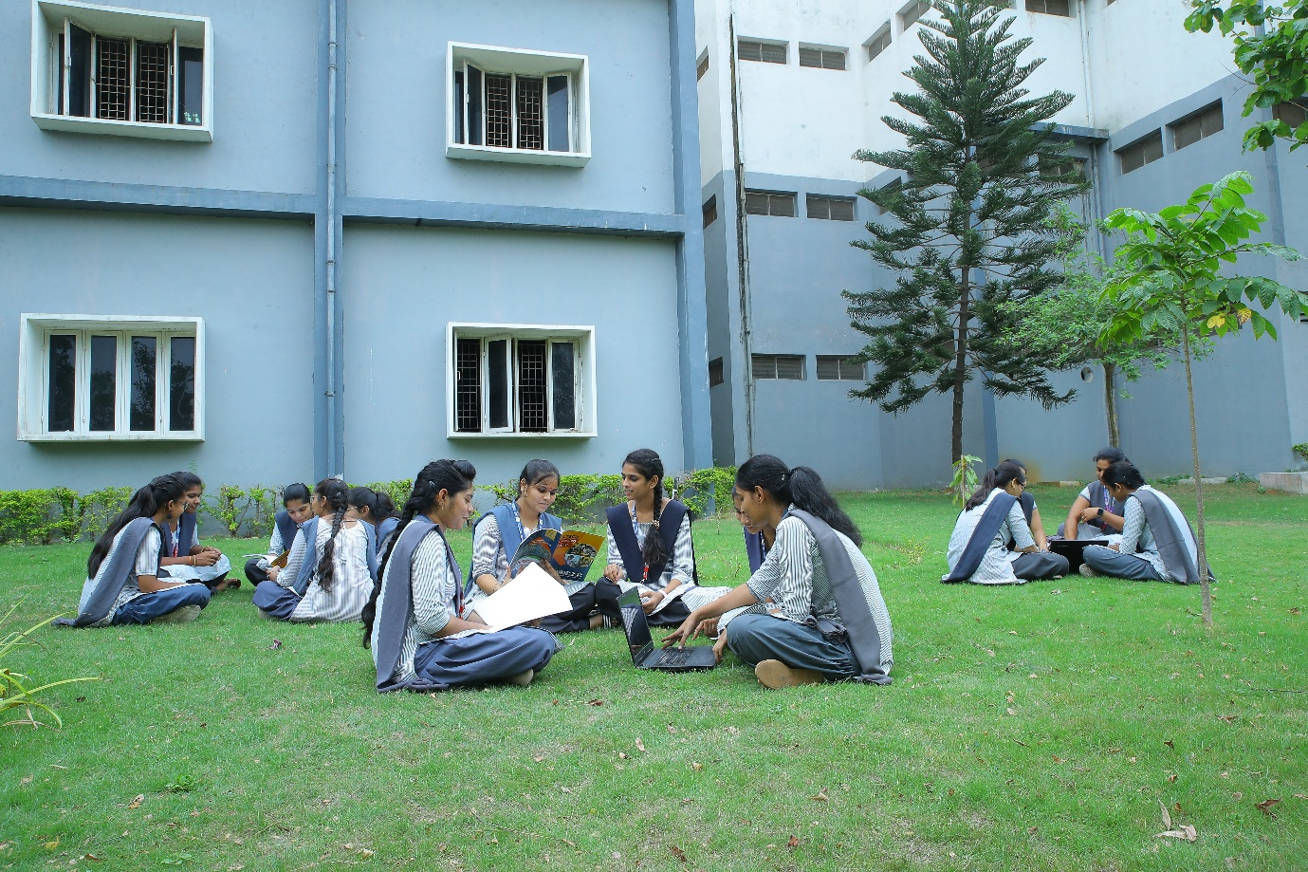

ABOUT
ABOUT US
The Department of Electronics and Communication Engineering was started in the year 2008 with an intake of 60 students in B. Tech. programme. The intake was enhanced subsequently and the present intake is 180.For this Academic Year(i.e 2023-24) a new B.Tech course in VLSI with 60 seats is issued by AICTE.The department also offers one PG programme, ,M.Tech (Digital Electronics and Communication Systems) which was started in the year 2012 with an intake of 18. The department has a team of highly qualified and experienced teaching faculty. The department has good infrastructural facilities and has full-fledged laboratories equipped with adequate state-of-the-art equipment and latest software The UG programme of the department is accredited thrice by AICTE-NBA. The department is recognized as Research Centre by JNTUK, Kakinada. The department has Embedded Systems and Robotics Lab which was established under IIT Bombay E-Yantra Project. The department has vibrant atmosphere for the students to emphasize on fundamentals and concepts focusing on analysis and design of various applications to fulfil the needs of industry. The department encourages faculty members and research scholars to carryout their research.
Department of Electronics and Communication Engineering&VLSI Block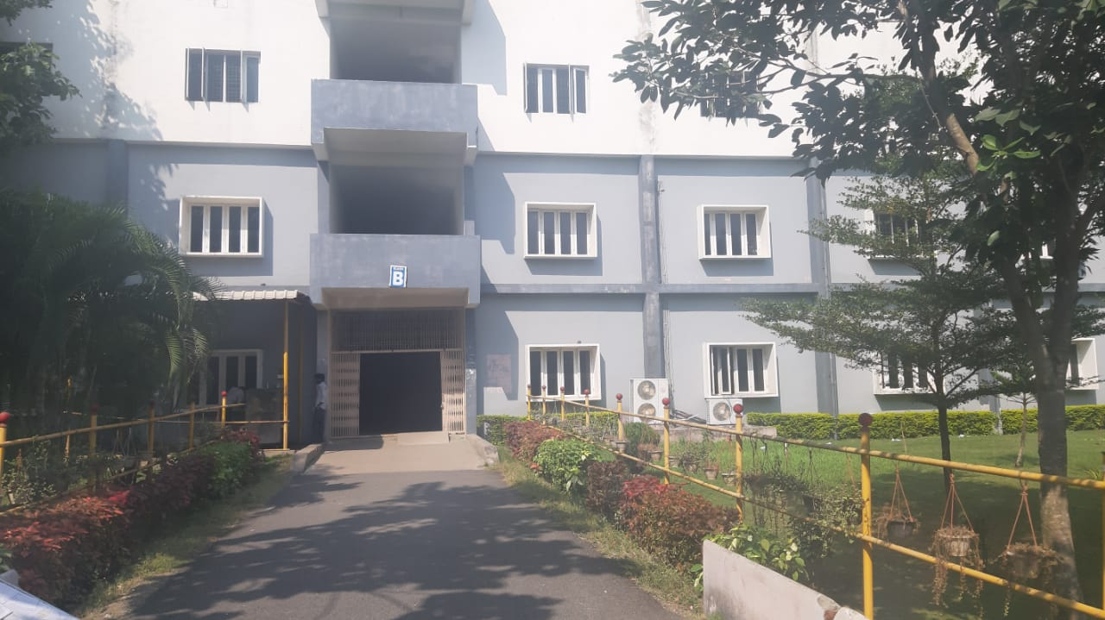
ECE DEPARTMENT VISION
To become a centre of excellence by bringi out the professional competence in the core areas of electronics and communication engineeri
DEPARTMENT MISSION
DMI: To provide conducive environment that impart electronics and communication knowledge through quality teaching & self-learning.
DM2: To serve the needs of electronics, telecommunication and allied industries through industry interaction.
DM3: TO Encourage innovative thinking, continuous learning an-long the stakeholders and create new techniques in IOT, VLSI.
DM4: To Groom students in communication and interpersonal skills.
DM5:: TO Inculcate human values and ethics to make learners sensitive towards social
PROGRAMME EDUCATIONAL OBJECTIVES
PEOI: Graduates with competencies in the area of electronics and communication engineering.
PE02: Graduates with continuous learning ability in hardware and software systems,in industry, research with technical and
PE03: Graduates with successful c interpersonal skills.
PE04; Graduates with professional and values.
PE05; Graduate shall contribute to goals with individual and team work.
Program Educational Objegtives (PEQs)
PEOI: Graduates with competencies in the area of electronics and communication engineering
PE02: Graduates with continuous leaming ability in hardware and software systems.
PE03: Graduate with successåll career in industry, research with technical and interpersonal skills.
PE04Graduate with professional and ethical values
Graduate shall contribute to organizational goals with individual and team work.
PROGRAM SPECIFIC OUTCOMES(PSOs)
PSOI
Professional Knowledge
Apply the concepts of Electronics and Communications to arrive cost effective and appropriate solutions
PS02
Problem-solving skills
Apply the principles of analog, digital and Signal processing systems for Consumer electronics, medical and radar systems
PS03
Software Usage
Use VHDL, MATLAB, MULTISIM and MENTOR GRAPHICS to design integrated circuits and analyze signals
PROGRAM OUTCOMES(POs)
1. Engineering knowledge: Apply the knowledge of mathematics, science, fundamentals, and an engineering specialization to the solution of complex problems.
2. Problem analysis: Identify, formulate, research literature, and analyze complex engineering problems reaching substantiated conclusions using first principles of mathematics, natural sciences, and engineering sciences.
3. Design/development Of solutions: Design solutions for complex engineering problems and design system components or processes that meet the specified needs with appropriate consideration for the public health and safety, and the cultural, societal, and environmental considerations.
4. Conduct investigations Of complex problems: Use research-based knowledge and research methods including design of experiments, analysis and interpretation of data, and synthesis of the information to provide valid conclusions.
5. Modern tool usage: Create, select, and apply appropriate techniques, resources, and modem engineering and IT tools including prediction and modeling to complex engineering activities with an understanding of the limitations.
6. The engineer and society: Apply reasoning informed by the contextual knowledge to assess societal, health, safety, legal and cultural issues and the consequent responsibilities relevant to the professional engineering practice.
7. Environment and sustainability: Understand the impact of the professional engineering solutions in societal and environmental contexts, and demonstrate the knowledge of, and need for sustainable development.
8. Ethics: Apply ethical principles and commit to professional ethics and responsibiliileg nd OW norms of the engineering practice. 9. Individual and team work: Function effectively as an individual, and as a member or leader in diverse teams, and in multidisciplinary settings
10.Communication: Communicate effectively on complex engineering activities with the engineering community and with society at large, such as, being able to comprehend and write effective repofls and design documentation, make effective presentations, and give and receive clear instructions.
11. Project management and finance: Demonstrate knowledge and understanding of the engineering and management principles and apply these to one's own work, as a member and leader in a team, to manage projects and in multidisciplinary environments.
12. Life-long learning: Recognize the need for, and have the preparation and ability to engage in independent and life-long learning in the broadest context of technological change.

ACADEMICS

Department Programs
B.Tech (ECE)
# | Regulations | Course Structure with Syllabus
1 | JNKTUK-R20 | I Year |  | II Year |  | III Year |  | IV Year
1 | JNKTUK-R20 | I_Semester | II_Semester | I_Semester | II_Semester | I_Semester | II_Semester | I_Semester | II_Semester
2 | JNKTUK-R19 | I Year |  | II Year |  | III Year |  | IV Year
2 | JNKTUK-R19 | I_Semester | II_Semester | I_Semester | II_Semester | I_Semester | II_Semester | I_Semester | II_Semester
3 | JNKTUK-R16 | I Year |  | II Year |  | III Year |  | IV Year
3 | JNKTUK-R16 | I_Semester | II_Semester | I_Semester | II_Semester | I_Semester | II_Semester | I_Semester | II_Semester
4 | JNKTUK-R13 | I Year |  | II Year |  | III Year |  | IV Year
4 | JNKTUK-R13 | I_Semester | II_Semester | I_Semester | II_Semester | I_Semester | II_Semester | I_Semester | II_Semester
M.Tech (Computer Science)
# | Regulations | Course Structure
1 | R19 | 1-1 Semester | 1-2 Semester | 2-1 Semester | 2-2 Semester
2 | R16 | I-1 Semester | II Semester

FACULTY
S.No. | NAME OF THE FACULTY | DESIGNATION | QUALIFICATION
1 | Dr.K.SRIHARI RAO | PROFESSOR & HEAD | M.E, Ph.D
2 | Dr.DOLA SANJAY.S | PROFESSOR | M.Tech, Ph.D
3 | Dr.C.KALAISELVAN | PROFESSOR | M.E, Ph.D
4 | Dr.SAIDAIAH BANDI | PROFESSOR | M.Tech, Ph.D
5 | Mrs.M.MARY JUNITHA | PROFESSOR | M.Tech
6 | Mrs.K.SUJATA | ASSOCIATE PROFESSOR | M.Tech
7 | Mrs.AMALA CHALLA | ASSOCIATE PROFESSOR | M.Tech
8 | Mr.P.MANOHAR | ASSOCIATE PROFESSOR | M.Tech
9 | Mr.CH.V.S.N. MURTHY | ASSOCIATE PROFESSOR | M.Tech
10 | Mrs.DARSI LAKSHMI | ASSISTANT PROFESSOR | M.Tech
11 | Mr.CH.RAMBABU | ASSISTANT PROFESSOR | M.Tech
12 | Ms.B.AKHILA | ASSISTANT PROFESSOR | M.Tech
13 | Ms.M.BHINDU SRI | ASSISTANT PROFESSOR | M.Tech
14 | Ms.D.SRAVYA | ASSISTANT PROFESSOR | M.Tech
15 | Mrs.V.NAGAJYOTHI | ASSISTANT PROFESSOR | M.Tech
16 | LALITHA RANI GOGINENI | ASSISTANT PROFESSOR | M.Tech
17 | K. SREEJA | ASSISTANT PROFESSOR | M.Tech
18 | Mrs.B.MEENAKSHI. | ASSISTANT PROFESSOR | M.Tech
19 | Mrs.VEERA VANI | ASSISTANT PROFESSOR | M.Tech
20 | Ms.P.PRAMEELA | ASSISTANT PROFESSOR | M.Tech
21 | Ms.M.MANASA | ASSISTANT PROFESSOR | M.Tech
22 | Ms.SHAIK SHANAZ | ASSISTANT PROFESSOR | M.Tech
23 | Ms.P.KANVITHA | ASSISTANT PROFESSOR | M.Tech
24 | Mr. UMMANENI ANJANEYULU | ASSISTANT PROFESSOR | M.Tech
25 | Mrs.K.TRIVENI LAKSHMI | ASSISTANT PROFESSOR | M.Tech
26 | Mr. HANIEF BHASHA | ASSISTANT PROFESSOR | M.Tech
27 | Mr.SHAIK BABA FARIDDIN | ASSISTANT PROFESSOR | M.Tech
28 | Ms.PAMARTI SREE LAKSHMI | ASSISTANT PROFESSOR | M.Tech
29 | Mr.V.GAJENDRA KUMAR | ASSISTANT PROFESSOR | M.E
30 | Mr.K. MURALI BABU | ASSISTANT PROFESSOR | M.E
31 | Mr.K. JAYA KUMAR | ASSISTANT PROFESSOR | M.E

INFRASTRUCTURE
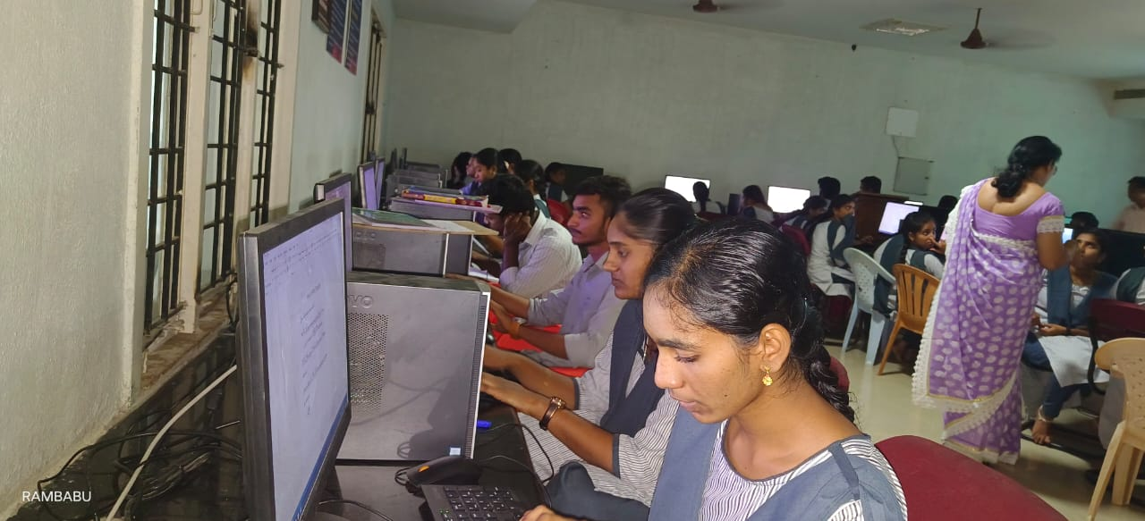

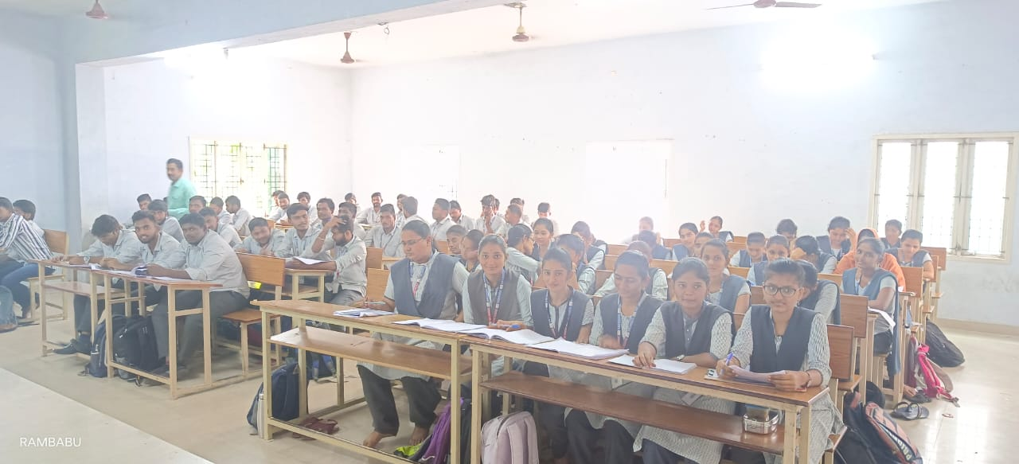

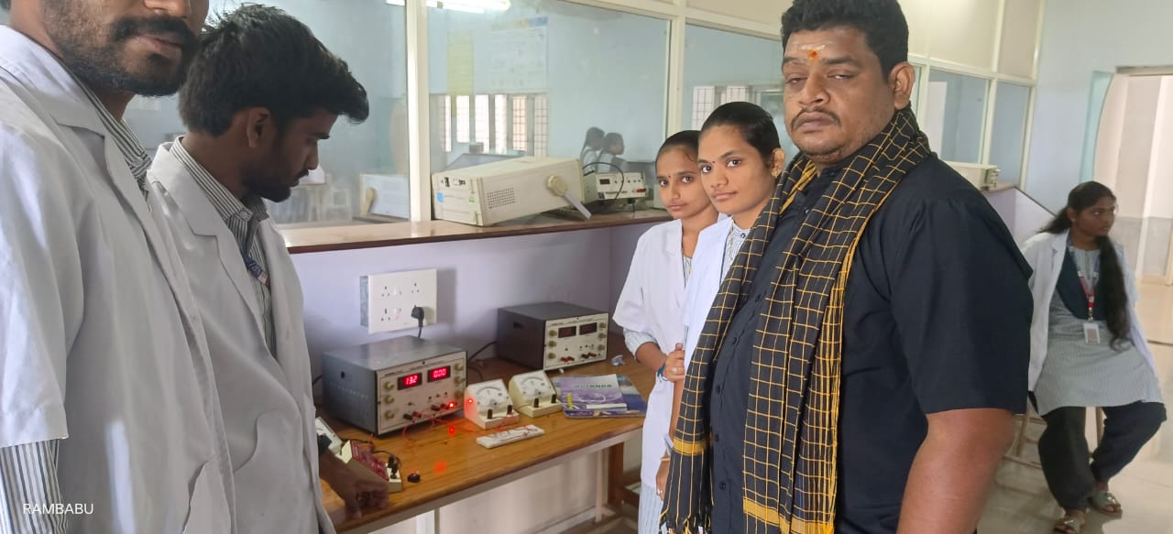

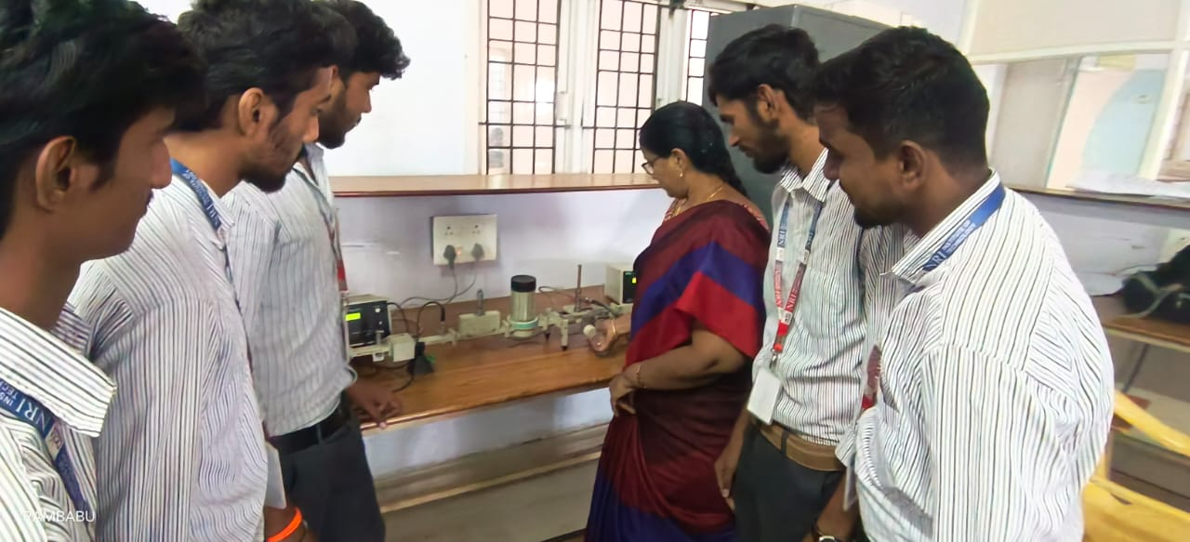

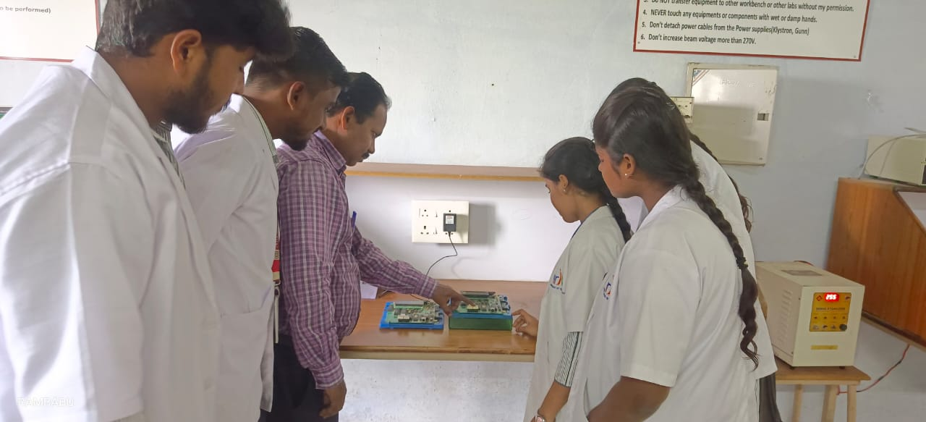

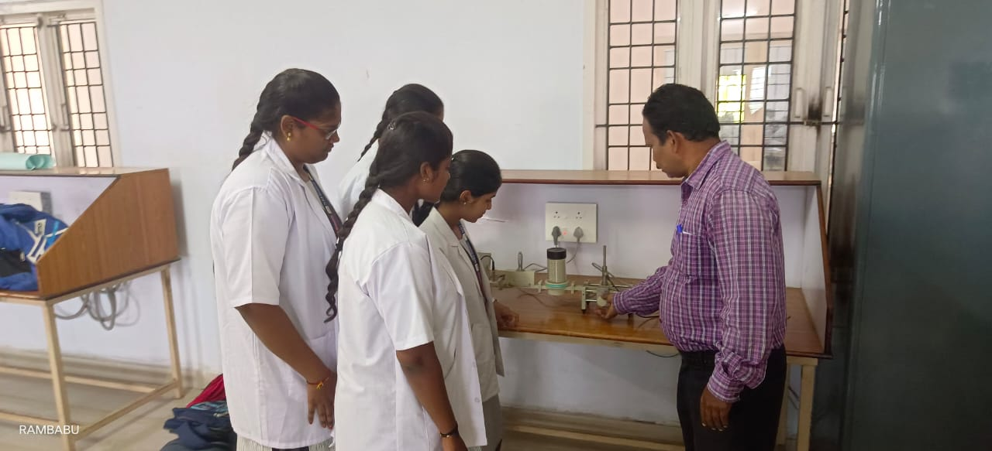

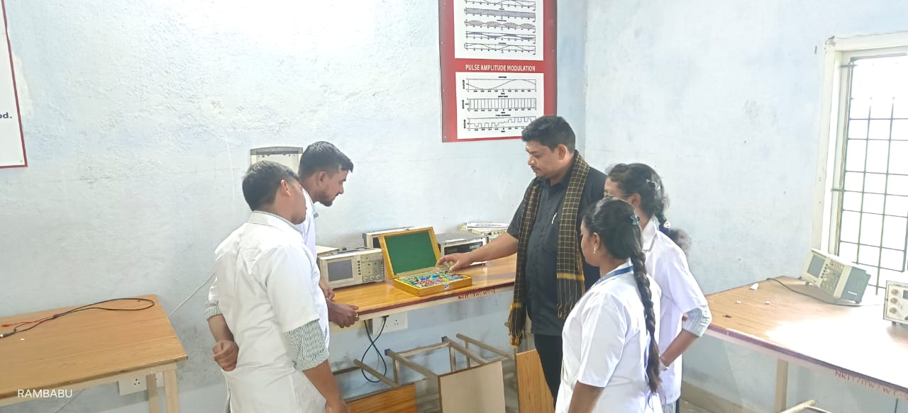

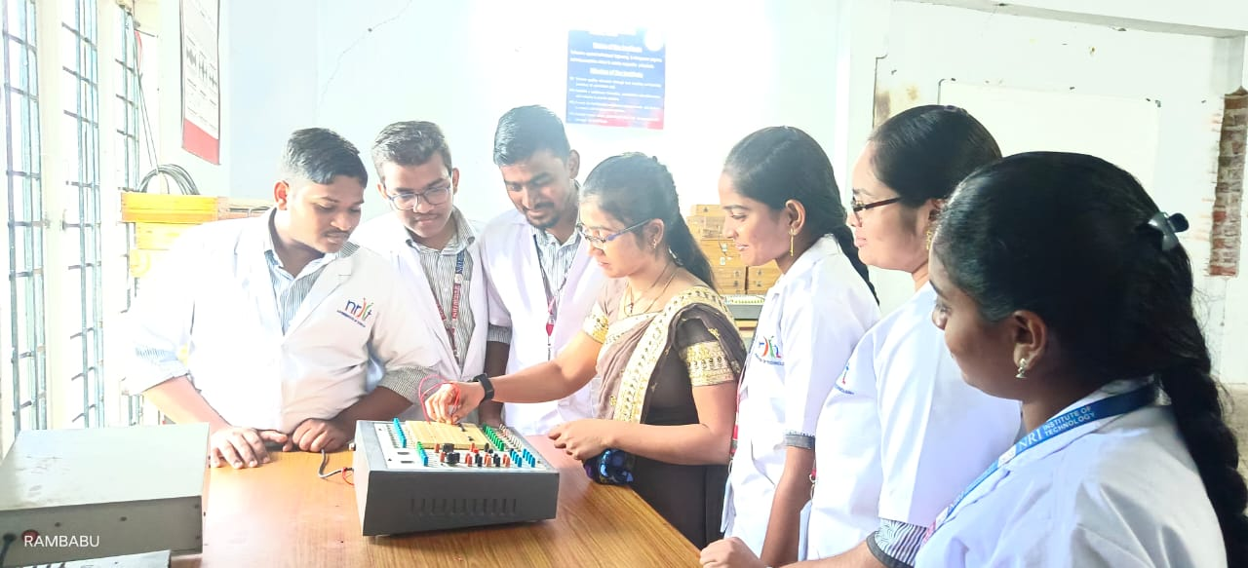

ACTIVITIES
Aptitude & Technical Skills
Sl.No | Name of the program | Data | Venue
1 | Communication Skills | All the year Students | Respective Class Rooms

An aptitude may be physical or mental. Aptitude is inborn potential to do certain kinds of work whether developed or undeveloped. Ability is developed knowledge, understanding, learned or acquired abilities (skills) or attitude.
1.Big Data Analysis. Nearly every industry today relies on data, whether it is data about their clients or the success of their product.
2.Coding and Programming
3.Project Management.
4.Social Media Experience
5.Technical Writing.
Improve Your Technical Skills:
1. Read technical books. One of the best ways to improve your technical skills is by reading books.
2. Read online tutorials.
3. Hang out with geeks.
4 Subscribe to technical magazines.
5 Take classes.
6 Create your own web site.
7 Build your own PC.
8 Embrace a variety of software.
Sl.No | Name of the program | Data | Venue
1 | Technical Skills | All the year Students | Respective Class Rooms

Summary Report Communication Skills
1. Excellent written and verbal communication skills.
2. Confident, articulate and professional speaking abilities (and experience)
3. Empathic listener and persuasive speaker.
4. Writing creative or factual.
5. Speaking in public, to groups, or via electronic media.
6. Excellent presentation and negotiation skills.

Communication skills the hiring manager will be evaluating:
1. Listening.
2. Confidence.
3. Empathy.
4. Friendliness (are you easy to talk to?)
5. Nonverbal communication (do you appear to be stressed or uncomfortable?)
6. Respect.
7. How clear and concise your responses.
Communication skills are also a main role for self-confidence. Communication is like conveying our messages to other people with clarity and obviously. Through communications, we can share our ideas and think throughout the country. If our communication is poor, it will do not reflect our thoughts and ideas what we really think.Across these qualities, love is one of the things that binds us each other. Love opens the main gates and it is the gate to all secrets of the universe. Everything can be gained in love across the world. A group of various main qualities those are faith, commitment, hard work, courage, communication skills and love these all things will lead to self-confidence. It is easy to obtain and self-confidence is easy to learn and develop yourself.
Sl.No | Name of the program | Data | Venue
1 | Soft Skills | All the year Students | Respective Class Rooms

Summary Report Soft Skills:Soft skills are a combination of people skills, social skills, communication skills, character or personality traits, attitudes, career attributes, social intelligence and emotional intelligence quotients, among others, that enable people to navigate their environment, work well with others, perform welland achieve. Soft skills' are skills that are desired by employers but are not job-specific. Learn more about the most important soft skills and how to develop them.Soft skills are character traits and interpersonal skills that characterize a person's relationships with other people. In the workplace, soft skills are considered to be a complement to hard skills, which refer to a person's knowledge and occupational skills.
The term soft skill refers to the personal traits, characteristics and competencies that inform to how an individual relates to others. One reason soft skills are so revered is that they help facilitate human connections. “Soft skills are key to building relationships, gaining visibility and creating. Soft skills are the set of behaviors and personality traits you use every day. Highlighting and developing strong soft skills can help you in the job search process.
Definition of soft skill:
Communicating, conflict management, human relations, making presentations, negotiating, team building, and other such ability, during conversations with customers and co-workers, getting and receiving messages from one another is essential to resolving concerns and in general getting things done. Understanding what soft skills are and how to use them is key.
Sl.No | Name of the program | Data | Venue
1 | JUST A MINUTE (JAM) | All the year Students | Respective Class Rooms

JUST A MINUTE (JAM)
JAM is the acronym of the JUST A MINUTE. It is the one of the Round in some interviews. The jam session is organized by the Company recruitment board for the candidates those who have attended for the Job interview. By arranging the JAM SESSION, Interviewers will have the chance to check the Talent and some of the skills of the Candidates. The interviewer will check the applicant’s skills, to test all the skills of the applicant JUST A MINUTE ROUND will be organized. Sometimes an interviewer will give you the JAM TOPIC and some other time interviewer will give a chance to select your own JAM Topic to talk in the JAM Session. Here are the just a minute topics latest, Choose any one from latest topics for just a minute round and give your best in jam just a minute session.
• General Knowledge
• Self-confidence
• Communication skills
• Spoken English & fluency
• The flow of thoughts & also the speech.
• Spontaneity
• Time management
• Sense of Humour
Sl.No | Name of the program | Data | Venue
1 | Group Discussion | All the year Students | Respective Class Rooms

Group Discussion:
Group discussion refers to a communicative situation that allows its participants to share their views and opinions with other participants. It is a systematic exchange of information, views and opinions about a topic, problem, issue or situation among the members of a group who share some common objectives.
Please go through some crucial group discussion skills below to craft your very own GD strategy accordingly.
• Reasoning. Try to find the GD topic category that you are comfortable with.
• Speaking.
• Time Management.
• Presentation.
• Paraphrasing/summarizing.
• Creativity.
• Listening.
• Proactive.
• Train yourself to be a good listener.
• Acknowledge that everyone has something valuable to say.
• When speaking in a GD, your job is to articulate your point of view in a way that is easy for others to comprehend.
• Inculcate the good habit of structuring your thoughts and presenting them logically.
"Discussion" is the process whereby two or more people exchange information or ideas in a face-to-face situation to achieve a goal. It is a systematic exchange of information, views and opinions about a topic, problem, issue or situation among the members of a group who share some common objectives.

Sl.No | Name of the program | Data | Venue
1 | QUIZ | All the year Students | Respective Class Rooms

Summary Report Quiz:
A quiz can function throughout a course as an informative feedback device allowing both the instructor and the students to see where they are excelling or need more focus. In order to effectively create exams and quizzes, it is important to establish and understand the learning objectives that are being measured.
A quiz is a form of game or mind sport, in which the players (as individuals or in teams) attempt to answer questions correctly. It is a game to test your knowledge about a certain subject. In some countries, a quiz is also a brief assessment used in education and similar fields to measure growth in knowledge, abilities, and/or skills.
Quizzes are usually scored in points and many quizzes are designed to determine a winner from a group of participants – usually the participant with the highest score. They may also involve eliminating those who get too many questions wrong, the winner being the last man standing. Quizzes may be held on a variety of subjects (general knowledge or 'pot luck' (which could be anything)) or subject-specific. The format of the quiz can also vary. Popularly known competition quizzes include • Pub quizzes • Quiz bowl In an educational context, a quiz is usually a form of a student assessment, but often has fewer questions of lesser difficulty and requires less time for completion than a test.
Sl.No | Name of the program | Data | Venue
1 | Debate | All the year Students | Respective Class Rooms

Summary Report Debate:
Debate is a process that involves formal discussion on a particular topic. In a debate, opposing arguments are put forward to argue for opposing viewpoints. Debate occurs in public meetings, academic institutions, and legislative assemblies. It is a formal type of discussion, often with a moderator and an audience, in addition to the debate participants.
Logical consistency, factual accuracy and some degree of emotional appeal to the audience are elements in debating, where one side often prevails over the other party by presenting a superior "context" or framework of the issue. In a formal debating contest, there are rules for participants to discuss and decide on differences, within a framework defining how they will do it. Debating is carried out in debating chambers and assemblies of various types to discuss matters and to make resolutions about action to be taken, often by voting. Deliberative bodies such as parliaments, legislative assemblies, and meetings of all sorts engage in debates. In particular, in parliamentary democracies a legislature debates and decides on new laws. Formal debates between candidates for elected office, such as the leader’s debates, are sometimes held in democracies. Debating is also carried out for educational and recreational purposes, usually associated with educational establishments and debating societies.

Placements
Placement cell has been functioning in our campus since 2016. The cell interacts with reputed organizations in order to arrange campus interviews for placement of final year ECE students. The placement cell also arranges internship for students in industries. Training and Placement (T&P) cell acts as an interface between institute of companies and maintain symbiotic and purposeful relationship with industries across the states. It has built up an impressive placement record both in terms of number of students placed as well as number of companies visiting the campus.
T&P cell invites companies for on-campus and ensures aspirant students of a bright career on his/her choice. Seminar halls and training halls have been made available to the students for conducting the training and recruitment programmes. T&P cell caters to the needs of the students by providing training programmes that are inculcated with the regular academic schedule. The prime focus does not rest upon pre-final and final year students but the training programmes encompass all the students from the second year. Training is being conducted through internal and external trainers. The Department placement and training coordinators assist campus interviews and training programmes.

PLACEMENTS IN YEARS
2021-22: Placements

SL.NO | ACADEMIC YEAR | Name of the student | PROGRAM GRADUATED FROM | NAME OF THE EMPLOYER CONTACT DETAILS | Pay Package
1 | 2021-22 | DARSI BARGAV | ECE | TCS | 4.08 LPA
2 | 2021-22 | GIRIDHAR GOPI KRISHNA DRONAMRAJU | ECE | TCS | 4.08 LPA
3 | 2021-22 | KARLAPUDI KRISHNA VAMSI | ECE | WIPRO | 3.5 LPA
4 | 2021-22 | POKURI ROOPASRI | ECE | WIPRO | 3.5 LPA
5 | 2021-22 | BOLLIMUNTHA ANKAMARAO | ECE | WIPRO | 3.5 LPA
6 | 2021-22 | N.KEERTHI | ECE | WIPRO | 3.5 LPA
7 | 2021-22 | MARRI SARVAN | ECE | WIPRO | 3.5 LPA
8 | 2021-22 | KALAPALA RAJARAJESWARI | ECE | WIPRO | 3.5 LPA
9 | 2021-22 | BEZAWADA NAGA VYSHNAVI | ECE | WIPRO | 3.5 LPA
10 | 2021-22 | BODDAPATI SIREESHA | ECE | WIPRO | 3.5 LPA
11 | 2021-22 | NARRA LAKSHMI NAGA MANIKANTA | ECE | WIPRO | 3.5 LPA
12 | 2021-22 | ADDA JYOTHI SAI LAKSHMI | ECE | INFOSYS | 3.6 LPA
13 | 2021-22 | ROMPICHARLA SRI LALITHA | ECE | INFOSYS | 3.6 LPA
14 | 2021-22 | SYED ISHRATH | ECE | INFOSYS | 3.6 LPA
15 | 2021-22 | KUKATLA KIRANMAI | ECE | INFOSYS | 3.6 LPA
16 | 2021-22 | GUDIPUDI LAKSHMI PRASANNA | ECE | INFOSYS | 3.6 LPA
17 | 2021-22 | NARRA LAKSHMI NAGA MANIKANTA | ECE | INFOSYS | 3.6 LPA
18 | 2021-22 | NARRA LAKSHMI NAGA MANIKANTA | ECE | HCL | 4.35 LPA
19 | 2021-22 | SAJJA NAGA SUPRIYA | ECE | HCL | 4.35 LPA
20 | 2021-22 | KUKATLA KIRANMAI | ECE | CAPGEMINI | 4 LPA
21 | 2021-22 | SYED ISHRATH | ECE | CAPGEMINI | 4 LPA
22 | 2021-22 | VADLAMUDI NAGADEEPIKA | ECE | VPG Sensors | 1.8 LPA
23 | 2021-22 | INTURI HEMASRI | ECE | VPG Sensors | 1.8 LPA
24 | 2021-22 | SRIDHARA DHARANI | ECE | VPG Sensors | 1.8 LPA
25 | 2021-22 | SHAIK MAHABOONI | ECE | VPG Sensors | 1.8 LPA
26 | 2021-22 | KUKATLA KIRANMAI | ECE | VPG Sensors | 1.8 LPA
27 | 2021-22 | NUSUMU RAMYA | ECE | VPG Sensors | 1.8 LPA
28 | 2021-22 | ROMPICHARLA SRI LALITHA | ECE | VPG Sensors | 1.8 LPA
29 | 2021-22 | SHAIK BAJI | ECE | VPG Sensors | 1.8 LPA
30 | 2021-22 | DASARI RAMYA | ECE | VPG Sensors | 1.8 LPA
31 | 2021-22 | ADDA JYOTHI SAI LAKSHMI | ECE | VPG Sensors | 1.8 LPA
32 | 2021-22 | BEZAWADA NAGA VYSHNAVI | ECE | VPG Sensors | 1.8 LPA
33 | 2021-22 | ANNAVARAPU TEJASWI | ECE | VPG Sensors | 1.8 LPA
34 | 2021-22 | KALAPALA RAJARAJESWARI | ECE | VPG Sensors | 1.8 LPA
35 | 2021-22 | PUTTA SUVARCHALA | ECE | VPG Sensors | 1.8 LPA
36 | 2021-22 | DODDA SRAVANI | ECE | VPG Sensors | 1.8 LPA
37 | 2021-22 | BODDAPATI SIREESHA | ECE | VPG Sensors | 1.8 LPA
38 | 2021-22 | KADIYALA NIKHILA | ECE | VPG Sensors | 1.8 LPA
39 | 2021-22 | BOLLIMUNTHA ANKAMMA RAO | ECE | VPG Sensors | 1.8 LPA
40 | 2021-22 | JANGAM PRAKASH CHANDRA | ECE | VPG Sensors | 1.8 LPA
41 | 2021-22 | RAAVI VIJAY KUMAR | ECE | VPG Sensors | 1.8 LPA
42 | 2021-22 | ADDANKI CHAKRADHAR | ECE | VPG Sensors | 1.8 LPA
43 | 2021-22 | PATHA SUNIL BABU | ECE | VPG Sensors | 1.8 LPA
44 | 2021-22 | NARRA LAKSHMI NAGA MANIKANTA | ECE | VPG Sensors | 1.8 LPA
45 | 2021-22 | PASYAVULA NAGA ANIL KUMAR | ECE | VPG Sensors | 1.8 LPA
46 | 2021-22 | DARSI BARGAV | ECE | VPG Sensors | 1.8 LPA
47 | 2021-22 | KARLAPUDI KRISHNA VAMSI | ECE | VPG Sensors | 1.8 LPA
48 | 2021-22 | KONDAMEEDA VENKATA GANESH | ECE | VPG Sensors | 1.8 LPA
49 | 2021-22 | MARRI SARVAN | ECE | VPG Sensors | 1.8 LPA
50 | 2021-22 | MAMIDALA PAVAN KALYAN | ECE | VPG Sensors | 1.8 LPA
51 | 2021-22 | VISSAMSETTI KALIKRISHNA NIKHIL | ECE | VPG Sensors | 1.8 LPA
52 | 2021-22 | YADAVARAPU VINAY KUMAR | ECE | VPG Sensors | 1.8 LPA
53 | 2021-22 | PILLALA LEELA KRISHNA | ECE | VPG Sensors | 1.8 LPA
54 | 2021-22 | SYED ISHRATH | ECE | VPG Sensors | 1.8 LPA
55 | 2021-22 | SUNDU SRI RAMANJANA DEVI | ECE | SAVANTIES HCL | 3.2 LPA
56 | 2021-22 | S.DHARANI | ECE | SAVANTIES HCL | 3.2 LPA
57 | 2021-22 | P.FIROZ KHAN | ECE | SAVANTIES HCL | 3.2 LPA
58 | 2021-22 | R.SRILALITHA | ECE | SAVANTIES HCL | 3.2 LPA
59 | 2021-22 | NAGAVYSHNAVI | ECE | SAVANTIES HCL | 3.2 LPA
60 | 2021-22 | A.JYOTHI SAI LAKSHMI | ECE | SAVANTIES HCL | 3.2 LPA
61 | 2021-22 | P.SIRDIVYA | ECE | SAVANTIES HCL | 3.2 LPA
62 | 2021-22 | P.TRIVENI | ECE | SAVANTIES HCL | 3.2 LPA
63 | 2021-22 | J.PRAKASHCHANDRA | ECE | SAVANTIES HCL | 3.2 LPA
64 | 2021-22 | B..MADHURI | ECE | SAVANTIES HCL | 3.2 LPA
65 | 2021-22 | M.SARVAN | ECE | SAVANTIES HCL | 3.2 LPA
66 | 2021-22 | CH.PRIYANKA | ECE | SAVANTIES HCL | 3.2 LPA
67 | 2021-22 | A.HARSHINI | ECE | SAVANTIES HCL | 3.2 LPA
68 | 2021-22 | N.LAKSHMI NAGA MANIKANTA | ECE | SAVANTIES HCL | 3.2 LPA
69 | 2021-22 | K.RAJESWARI | ECE | SAVANTIES HCL | 3.2 LPA
70 | 2021-22 | K.NIKHILA | ECE | SAVANTIES HCL | 3.2 LPA
71 | 2021-22 | G.TESWANI | ECE | SAVANTIES HCL | 3.2 LPA
72 | 2021-22 | L.LEELAVATHI | ECE | SAVANTIES HCL | 3.2 LPA
73 | 2021-22 | I.HEMASRI | ECE | SAVANTIES HCL | 3.2 LPA
74 | 2021-22 | SK.MAHABUNI | ECE | SAVANTIES HCL | 3.2 LPA
75 | 2021-22 | RAVANDRA MANI SURABHI | ECE | SAVANTIES HCL | 3.2 LPA
76 | 2021-22 | Vadlamudi Naga deepika | ECE | ZELF STUDIES | 6 LPA
77 | 2021-22 | AVUTHU HARSHINI | ECE | ZELF STUDIES | 6 LPA
78 | 2021-22 | Chakradhar addanki | ECE | ZELF STUDIES | 6 LPA
79 | 2021-22 | Keerthi Nimmagadda | ECE | ZELF STUDIES | 6 LPA
80 | 2021-22 | Syed Ishrath | ECE | ZELF STUDIES | 6 LPA
81 | 2021-22 | Pallothu Triveni | ECE | ZELF STUDIES | 6 LPA
82 | 2021-22 | Bezawada Nagavyshnavi | ECE | ZELF STUDIES | 6 LPA
83 | 2021-22 | Sai kiran vithal sandu | ECE | ZELF STUDIES | 6 LPA
84 | 2021-22 | Paleru yojana | ECE | ZELF STUDIES | 6 LPA
85 | 2021-22 | Inturi.hemasri | ECE | ZELF STUDIES | 6 LPA
86 | 2021-22 | SHAIK MAHABOONI | ECE | ZELF STUDIES | 6 LPA
87 | 2021-22 | Lala.Leelavathi | ECE | ZELF STUDIES | 6 LPA
88 | 2021-22 | Alla silpa | ECE | ZELF STUDIES | 6 LPA
89 | 2021-22 | Nagasupriya Sajja | ECE | ZELF STUDIES | 6 LPA
90 | 2021-22 | BODDAPATI SIREESHA | ECE | ZELF STUDIES | 6 LPA
91 | 2021-22 | Jangam Prakash Chandra | ECE | ZELF STUDIES | 6 LPA
92 | 2021-22 | Atluri srivalli | ECE | ZELF STUDIES | 6 LPA
93 | 2021-22 | Dhanekula Likhithsai | ECE | ZELF STUDIES | 6 LPA
94 | 2021-22 | Pathan Firoz khan | ECE | ZELF STUDIES | 6 LPA
95 | 2021-22 | Gaddam Tejaswi | ECE | ZELF STUDIES | 6 LPA
96 | 2021-22 | Kalapala Rajarajeswari | ECE | ZELF STUDIES | 6 LPA
97 | 2021-22 | CHENAKESAVULU PRIYANKA | ECE | Q SPIDERS | 3.6 LPA
98 | 2021-22 | PASULATI SINDHU PRIYA | ECE | Q SPIDERS | 3.6 LPA
99 | 2021-22 | BOLLIMUNTHA ANKAMMA RAO | ECE | Q SPIDERS | 3.6 LPA
100 | 2021-22 | IMMADI NAVEEN | ECE | Q SPIDERS | 3.6 LPA
101 | 2021-22 | NUSUMU RAMYA | ECE | Q SPIDERS | 3.6 LPA
102 | 2021-22 | VENKATA SIVA RAO BOLLIMUNTHA | ECE | Q SPIDERS | 3.6 LPA
103 | 2021-22 | NAVYASRI M | ECE | Q SPIDERS | 3.6 LPA
104 | 2021-22 | NARRA LAKSHMI NAGA MANIKANTA | ECE | BYJU'S | 10 LPA
105 | 2021-22 | N.BHANU PRAKASH | ECE | SPR HUMAN CAPITAL SOLUTIONS | 2.25 LPA
106 | 2021-22 | P.LEE KRISHNA | ECE | SPR HUMAN CAPITAL SOLUTIONS | 2.25 LPA
107 | 2021-22 | SK.BAJIVALI | ECE | SPR HUMAN CAPITAL SOLUTIONS | 2.25 LPA
108 | 2021-22 | P.NAGA ANILKUMAR | ECE | SPR HUMAN CAPITAL SOLUTIONS | 2.25 LPA
109 | 2021-22 | S.PAVAN KRISHNA | ECE | SPR HUMAN CAPITAL SOLUTIONS | 2.25 LPA
110 | 2021-22 | R.VIJAY KUMAR | ECE | SPR HUMAN CAPITAL SOLUTIONS | 2.25 LPA
111 | 2021-22 | S.SAI KIRAN VITHAL | ECE | SPR HUMAN CAPITAL SOLUTIONS | 2.25 LPA
112 | 2021-22 | P.VIJAY ANANDH | ECE | SPR HUMAN CAPITAL SOLUTIONS | 2.25 LPA
113 | 2021-22 | Y.Y.V.N SIVA SAI | ECE | SPR HUMAN CAPITAL SOLUTIONS | 2.25 LPA
114 | 2021-22 | G.LAKSHMI KHANTH REDDY | ECE | SPR HUMAN CAPITAL SOLUTIONS | 2.25 LPA
115 | 2021-22 | V.SESHA MANIKANTA | ECE | SPR HUMAN CAPITAL SOLUTIONS | 2.25 LPA
116 | 2021-22 | P.RAMAKRISHNA | ECE | SPR HUMAN CAPITAL SOLUTIONS | 2.25 LPA
117 | 2021-22 | V.VENKATA SIVA NAGARAJU | ECE | SPR HUMAN CAPITAL SOLUTIONS | 2.25 LPA
118 | 2021-22 | V.NIKHIL | ECE | SPR HUMAN CAPITAL SOLUTIONS | 2.25 LPA
119 | 2021-22 | S.LEELAPRASAD | ECE | SPR HUMAN CAPITAL SOLUTIONS | 2.25 LPA
120 | 2021-22 | DINESH T | ECE | SPR HUMAN CAPITAL SOLUTIONS | 2.25 LPA
121 | 2021-22 | S VINAY KUMAR | ECE | SPR HUMAN CAPITAL SOLUTIONS | 2.25 LPA
122 | 2021-22 | P VIRA REDDY | ECE | SPR HUMAN CAPITAL SOLUTIONS | 2.25 LPA
123 | 2021-22 | Naga satyadeep Jandhyam | ECE | FIXITY TECHNOLOGY | 3.5 LPA
124 | 2021-22 | DODDA SRAVANI | ECE | TECH MAHINDRA | 2.05 LPA

2020-21: Placements
SL.NO | ACADEMIC YEAR | Name of the student | PROGRAM GRADUATED FROM | NAME OF THE EMPLOYER CONTACT DETAILS | Pay Package
1 | 2020-21 | Shaik Hasan Ahmed | ECE | VVV INFOTECH | 4.9LPA
2 | 2020-21 | Neelapala.Sravani | ECE | VVV INFOTECH | 4.9LPA
3 | 2020-21 | Botta Lakshmi Meghana | ECE | VVV INFOTECH | 4.9LPA
4 | 2020-21 | Muppavarapu Durga Bhavani | ECE | VVV INFOTECH | 4.9LPA
5 | 2020-21 | Vishnumolakala sivapriya | ECE | VVV INFOTECH | 4.9LPA
6 | 2020-21 | Takkellapati Navya | ECE | VVV INFOTECH | 4.9LPA
7 | 2020-21 | Bhanu Prakash Andela | ECE | Capgemini | 3.5LPA
8 | 2020-21 | Tagore Rama Sai nadh | ECE | Capgemini | 3.5LPA
9 | 2020-21 | Guggilam Prudhvi Krishna | ECE | Capgemini | 3.5LPA
10 | 2020-21 | P. Venkata Pavan Kalyan | ECE | Capgemini | 3.5LPA
11 | 2020-21 | Swaroopa | ECE | Capgemini | 3.5LPA
12 | 2020-21 | Somineni vyshnavi | ECE | Capgemini | 3.5LPA
13 | 2020-21 | Muppavarapu Durga Bhavani | ECE | Cognizant | 3.5LPA
14 | 2020-21 | Takkellapati Navya | ECE | ILM | 2-2.5LPA
15 | 2020-21 | Lakshmi Meghana | ECE | ILM | 2-2.5LPA
16 | 2020-21 | Boddu Bidhu Madhuri | ECE | HCL | 3.2LPA
17 | 2020-21 | Shaik Hasan Ahmed | ECE | Infosys | 3.2LPA
18 | 2020-21 | Addanki Amrutha | ECE | Infosys | 3.2LPA
19 | 2020-21 | Sk.Shaheen salma | ECE | INFOSYS | 3.2LPA
20 | 2020-21 | Shaik Hasan Ahmed | ECE | QSPIDER | 2.65LPA
21 | 2020-21 | P.Sirisha | ECE | QSPIDER | 2.65LPA
22 | 2020-21 | T. Tirupatamma | ECE | QSPIDER | 2.65LPA
23 | 2020-21 | Y.Srilakshmi | ECE | QSPIDER | 2.65LPA
24 | 2020-21 | Shaik Abdullah | ECE | QSPIDER | 2.65LPA
25 | 2020-21 | Durga Bhavani | ECE | QSPIDER | 2.65LPA
26 | 2020-21 | Boddu Bidhu Madhuri | ECE | L-CUBE | 2.4-2.7LPA
27 | 2020-21 | Muppavarapu Durga Bhavani | ECE | L-CUBE | 2.4-2.7LPA
28 | 2020-21 | Laasya Sri Kolli | ECE | L-CUBE | 2.4-2.7LPA
29 | 2020-21 | Botta Lakshmi Meghana | ECE | L-CUBE | 2.4-2.7LPA
30 | 2020-21 | K.Sasidhar Reddy | ECE | TCS | 3.6LPA
31 | 2020-21 | Sireesha karumanchi | ECE | HTL | 2.4LPA
32 | 2020-21 | Mandadi Lakshmisai | ECE | HTL | 2.4LPA
33 | 2020-21 | Shaik Abdullah | ECE | HTL | 2.4LPA
34 | 2020-21 | Takkellapati Navya | ECE | HTL | 2.4LPA
35 | 2020-21 | DANABOINA GREESHMA VEENA | ECE | HTL | 2.4LPA
36 | 2020-21 | BELLAM VENKATESH | ECE | HTL | 2.4LPA
37 | 2020-21 | Shaik Hasan Ahmed | ECE | WIPRO | 3.1LPA
38 | 2020-21 | G.Prudhvi Krishna | ECE | Wipro | 3.1LPA
39 | 2020-21 | KONJETI SANDEEP | ECE | Wipro | 3.1LPA
40 | 2020-21 | Ms.M.S. Survana Lakshmi | ECE | Wipro | 3.1LPA
41 | 2020-21 | Shaik Hasan Ahmed | ECE | VEE TECHNOLOGIES | 2-4LPA
42 | 2020-21 | Neelapala.Sravani | ECE | VEE TECHNOLOGIES | 2-4LPA
43 | 2020-21 | Botta Lakshmi Meghana | ECE | VEE TECHNOLOGIES | 2-4LPA
44 | 2020-21 | Muppavarapu Durga Bhavani | ECE | VEE TECHNOLOGIES | 2-4LPA
45 | 2020-21 | Vishnumolakala sivapriya | ECE | VEE TECHNOLOGIES | 2-4LPA

2019-20: Placements
SL.NO | ACADEMIC YEAR | Name of the student | PROGRAM GRADUATED FROM | NAME OF THE EMPLOYER CONTACT DETAILS | Pay Package
1 | 2019-20 | K.B.LAKSHMI DEVI | ECE | ILM | 2-2.5LPA
2 | 2019-20 | CH.PRATYUSHA | ECE | ILM | 2.10LPA
3 | 2019-20 | J.RAMYA | ECE | ILM | 2.10LPA
4 | 2019-20 | H.BHANU PRAKASH | ECE | ILM | 2.10LPA
5 | 2019-20 | A.BAJIBABU | ECE | ILM | 2.10LPA
6 | 2019-20 | SK.ARSHAD | ECE | ILM | 2.10LPA
7 | 2019-20 | SK.RABBANI | ECE | ILM | 2.10LPA
8 | 2019-20 | P.YOJITHA | ECE | ILM | 2.10LPA
9 | 2019-20 | Y.ESWARI DEVI | ECE | ILM | 2.10LPA
10 | 2019-20 | Y.SUJATHA | ECE | ILM | 2.10LPA
11 | 2019-20 | Y.SITHARAMIREDDY | ECE | ILM | 2.10LPA
12 | 2019-20 | SK.ABDUL SATTAR | ECE | ILM | 2.10LPA
13 | 2019-20 | CH.NANDINI | ECE | TCS | 4.08LPA
14 | 2019-20 | U.JYOTHI PRAKASH | ECE | TCS | 4.08LPA
15 | 2019-20 | K.YAMUNA | ECE | TCS | 4.08LPA
16 | 2019-20 | P.YOJITHA | ECE | TCS | 4.08LPA
17 | 2019-20 | Y.SUJATHA | ECE | TCS | 4.08LPA
18 | 2019-20 | S.SRAVANI | ECE | TCS | 4.08LPA
19 | 2019-20 | SK.MD.GAYAZ | ECE | TCS | 4.08LPA
20 | 2019-20 | CH.N.V.S.S.RAJESWARI | ECE | TCS | 4.08LPA
21 | 2019-20 | MS.A.YASWITHA | ECE | TCS | 4.08LPA
22 | 2019-20 | BOLLA RAVI KUMAR | ECE | TCS | 4.08LPA
23 | 2019-20 | KORRAPATI SURESH | ECE | TCS | 4.08LPA
24 | 2019-20 | ETUKURI AVINASH | ECE | TCS | 4.08LPA
25 | 2019-20 | GHANTA SAI PRIYA | ECE | TCS | 4.08LPA
26 | 2019-20 | P.PRATYUSHA RANI | ECE | Q SPIDER TECHNOLOGIES | 2.20LPA
27 | 2019-20 | A.SOWMYA LAKSHMI | ECE | Q SPIDER TECHNOLOGIES | 2.20LPA
28 | 2019-20 | T.VENKATA KARTHIK | ECE | Q SPIDER TECHNOLOGIES | 2.20LPA
29 | 2019-20 | D.PURNIMA | ECE | Q SPIDER TECHNOLOGIES | 2.20LPA
30 | 2019-20 | CHOWTA RAM SAILESH | ECE | Q SPIDER TECHNOLOGIES | 2.20LPA
31 | 2019-20 | INOLU GURUSWAMI | ECE | Q SPIDER TECHNOLOGIES | 2.20LPA
32 | 2019-20 | KAZA TANUJA KRISHNA | ECE | Q SPIDER TECHNOLOGIES | 2.20LPA
33 | 2019-20 | YENUGANTI SUJATHA | ECE | Q SPIDER TECHNOLOGIES | 2.20LPA
34 | 2019-20 | NALI DEVENDRA BABU | ECE | Q SPIDER TECHNOLOGIES | 2.20LPA
35 | 2019-20 | DEEVI VISHNU CHAITANYA | ECE | Q SPIDER TECHNOLOGIES | 2.20LPA
36 | 2019-20 | GADIREDDY VENKATA SAIRAM | ECE | Q SPIDER TECHNOLOGIES | 2.20LPA
37 | 2019-20 | SHAIK RABBANI | ECE | Q SPIDER TECHNOLOGIES | 2.20LPA
38 | 2019-20 | T.VENKATA KARTHIK | ECE | WIPRO | 3.8LPA
39 | 2019-20 | P.ANUSHA | ECE | WIPRO | 3.8LPA
40 | 2019-20 | K.YAMUNA | ECE | WIPRO | 3.8LPA
41 | 2019-20 | K.N VENKATA LAVANYA | ECE | WIPRO | 3.8LPA
42 | 2019-20 | D.PURNIMA | ECE | CAPGEMINI | 4.1LPA
43 | 2019-20 | J.RAMYA | ECE | CAPGEMINI | 4.1LPA
44 | 2019-20 | Y.PRUDHVI | ECE | CAPGEMINI | 4.1LPA
45 | 2019-20 | L.RAMANA | ECE | CAPGEMINI | 4.1LPA
46 | 2019-20 | P.AMEER KHAN | ECE | CAPGEMINI | 4.1LPA
47 | 2019-20 | S.PREM GANESGH | ECE | CAPGEMINI | 4.1LPA
48 | 2019-20 | SK.MD.GAYAZ | ECE | CAPGEMINI | 4.1LPA
49 | 2019-20 | A.SOWMYA MULANKURAMMA | ECE | CAPGEMINI | 4.1LPA
50 | 2019-20 | K.VENKATA SRI RAM | ECE | CAPGEMINI | 4.1LPA
51 | 2019-20 | K.VENKATA SRILAKSHMAN | ECE | CAPGEMINI | 4.1LPA
52 | 2019-20 | T.VIJAY KUMAR | ECE | SPR HUMAN CAPITAL SOLUTIONS | 2.65 LPA
53 | 2019-20 | T.PRAVEEN KUMAR | ECE | SPR HUMAN CAPITAL SOLUTIONS | 2.65 LPA
54 | 2019-20 | GALAM RAMA RAO | ECE | SPR HUMAN CAPITAL SOLUTIONS | 2.65 LPA
55 | 2019-20 | KORRAPATI SURESH | ECE | SPR HUMAN CAPITAL SOLUTIONS | 2.65 LPA
56 | 2019-20 | BOCHU VENU | ECE | SPR HUMAN CAPITAL SOLUTIONS | 2.65 LPA
57 | 2019-20 | CHAVAPATI SAHEEL | ECE | SPR HUMAN CAPITAL SOLUTIONS | 2.65 LPA
58 | 2019-20 | BOLLU KAVYA SRI | ECE | SPR HUMAN CAPITAL SOLUTIONS | 2.65 LPA
59 | 2019-20 | MADDINA AVINASH | ECE | SPR HUMAN CAPITAL SOLUTIONS | 2.65 LPA
60 | 2019-20 | BADRI DHARANI | ECE | SPR HUMAN CAPITAL SOLUTIONS | 2.65 LPA
61 | 2019-20 | KOMMURI AKASH | ECE | SPR HUMAN CAPITAL SOLUTIONS | 2.65 LPA
62 | 2019-20 | ALAPATI GANESH | ECE | SPR HUMAN CAPITAL SOLUTIONS | 2.65 LPA
63 | 2019-20 | ANCHULA BALA SRINIVAS | ECE | SPR HUMAN CAPITAL SOLUTIONS | 2.65 LPA
64 | 2019-20 | SYED RASOOL | ECE | SPR HUMAN CAPITAL SOLUTIONS | 2.65 LPA
65 | 2019-20 | TULLA YADAGIRI | ECE | SPR HUMAN CAPITAL SOLUTIONS | 2.65 LPA
66 | 2019-20 | TADIKONDA ALEKHYA | ECE | SPR HUMAN CAPITAL SOLUTIONS | 2.65 LPA
67 | 2019-20 | DWARAKACHARLA RENUKA | ECE | ALIENS GROUP | 4.8LPA
68 | 2019-20 | GADDE SAINAVYA | ECE | ALIENS GROUP | 4.8LPA
69 | 2019-20 | GAMIDI LAKSHMAN | ECE | ALIENS GROUP | 4.8LPA
70 | 2019-20 | GANDAM VENKATAKISHOREKUMAR | ECE | ALIENS GROUP | 4.8LPA
71 | 2019-20 | ETUKURI AVINASH | ECE | ALIENS GROUP | 4.8LPA
72 | 2019-20 | ADITYA VARDHAN RAO BHONGIR | ECE | ALIENS GROUP | 4.8LPA
73 | 2019-20 | GANJI TULASI RAM | ECE | ALIENS GROUP | 4.8LPA
74 | 2019-20 | ADDEPALLI BHARATH KUMAR | ECE | ALIENS GROUP | 4.8LPA
75 | 2019-20 | GARIKAPATI YAMINI | ECE | ALIENS GROUP | 4.8LPA
76 | 2019-20 | GANDHAM SRI LAKSHMI | ECE | ALIENS GROUP | 4.8LPA
2 | 2019-20 | GHANTA SAI PRIYA | ECE | ALIENS GROUP | 4.8LPA

2018-19
SL.NO | ACADEMIC YEAR | Name of the student | PROGRAM GRADUATED FROM | NAME OF THE EMPLOYER CONTACT DETAILS | Pay Package
1 | 2018-19 | K.B.LAKSHMI DEVI | ECE | ILM | 2-2.5LPA
2 | 2018-19 | K.ASHA | ECE | ILM | 2-2.5LPA
3 | 2018-19 | K.N.TIRUMALA | ECE | ILM | 2-2.5LPA
4 | 2018-19 | N.MAHESWAR REDDY | ECE | ILM | 2-2.5LPA
5 | 2018-19 | P.S.SWAPNA | ECE | ILM | 2-2.5LPA
6 | 2018-19 | T.DIVYA TEJA | ECE | ILM | 2-2.5LPA
7 | 2018-19 | T.VENKATA SIVA NATH | ECE | ILM | 2-2.5LPA
8 | 2018-19 | T.RAVI TEJA | ECE | ILM | 2-2.5LPA
9 | 2018-19 | T.SIREESHA | ECE | ILM | 2-2.5LPA
10 | 2018-19 | K.BHARATH KUMAR | ECE | ILM | 2-2.5LPA
11 | 2018-19 | K.RESHMA | ECE | ILM | 2-2.5LPA
12 | 2018-19 | P.S.KUMAR | ECE | ILM | 2-2.5LPA
13 | 2018-19 | P.RAJESH | ECE | WEST LINE | 2.7-3.5LPA
14 | 2018-19 | M.ANUSHA | ECE | ALIENS GROUP | 4.8LPA
15 | 2018-19 | M.SRINIVAS | ECE | ALIENS GROUP | 4.8LPA
16 | 2018-19 | CH.KARTHIK | ECE | DHARANI TECHNOLOGIES | INR 90,000 – 2,75,000 P.A
17 | 2018-19 | CH.M.L.PRIYANKA | ECE | DHARANI TECHNOLOGIES | INR 90,000 – 2,75,000 P.A
18 | 2018-19 | D.DHARANI | ECE | DHARANI TECHNOLOGIES | INR 90,000 – 2,75,000 P.A
19 | 2018-19 | D.HARI KRISHNA | ECE | DHARANI TECHNOLOGIES | INR 90,000 – 2,75,000 P.A
20 | 2018-19 | M.S.CHOWDARY | ECE | DHARANI TECHNOLOGIES | INR 90,000 – 2,75,000 P.A
21 | 2018-19 | N.SOWMY | ECE | DHARANI TECHNOLOGIES | INR 90,000 – 2,75,000 P.A
22 | 2018-19 | P.VENNELA | ECE | DHARANI TECHNOLOGIES | INR 90,000 – 2,75,000 P.A
23 | 2018-19 | R.L.KRISHNA | ECE | DHARANI TECHNOLOGIES | INR 90,000 – 2,75,000 P.A
24 | 2018-19 | D.S.NARAYANA | ECE | DHARANI TECHNOLOGIES | INR 90,000 – 2,75,000 P.A
25 | 2018-19 | Y.M.LAKSHMI | ECE | DHARANI TECHNOLOGIES | INR 90,000 – 2,75,000 P.A
26 | 2018-19 | A.VANI VINEELA | ECE | GAGAN AAPS | 1LPA
27 | 2018-19 | A.KOUSIKA | ECE | GAGAN AAPS | 1LPA
28 | 2018-19 | B.GOPINADH | ECE | GAGAN AAPS | 1LPA
29 | 2018-19 | A.HARIKA | ECE | GAGAN AAPS | 1LPA
30 | 2018-19 | A.R.K REDDY | ECE | GAGAN AAPS | 1LPA
31 | 2018-19 | SK.HNEEF BASHA | ECE | GAGAN AAPS | 1LPA
32 | 2018-19 | A.R.K REDDY | ECE | VEE TECHNOLOGIES | 2-4LPA
33 | 2018-19 | K.KEERTHANA | ECE | VEE TECHNOLOGIES | 2-4LPA
34 | 2018-19 | KOTA CHAKRAPANI | ECE | VEE TECHNOLOGIES | 2-4LPA
35 | 2018-19 | YETURI VINEELA | ECE | VEE TECHNOLOGIES | 2-4LPA
36 | 2018-19 | A.S.PRAKASH | ECE | VEE TECHNOLOGIES | 2-4LPA
37 | 2018-19 | CH.S.NAGESWARA RAO | ECE | VEE TECHNOLOGIES | 2-4LPA
38 | 2018-19 | A.R.K REDDY | ECE | VEE TECHNOLOGIES | 2-4LPA
39 | 2018-19 | SK.HNEEF BASHA | ECE | VEE TECHNOLOGIES | 2-4LPA
40 | 2018-19 | A.R.K REDDY | ECE | VEE TECHNOLOGIES | 2-4LPA
41 | 2018-19 | SK.HNEEF BASHA | ECE | VEE TECHNOLOGIES | 2-4LPA
42 | 2018-19 | SAKINALA RENU | ECE | WIPRO | 3.8LPA
43 | 2018-19 | PALISETTI PAVANI | ECE | WIPRO | 3.8LPA
44 | 2018-19 | BANDLAMUDI DIVYA | ECE | WIPRO | 3.8LPA
45 | 2018-19 | EPURI AKSHAY | ECE | WIPRO | 3.8LPA
46 | 2018-19 | ADDANKI VENKATA SUNDEEP | ECE | WIPRO | 3.8LPA
47 | 2018-19 | BANDARUPALLI HARISH | ECE | WIPRO | 3.8LPA
48 | 2018-19 | PATCHALA MURALI | ECE | WIPRO | 3.8LPA
49 | 2018-19 | KHARIDU HITESH KUMAR | ECE | WIPRO | 3.8LPA
50 | 2018-19 | SANKU HARIKA | ECE | WIPRO | 3.8LPA
51 | 2018-19 | SIDDE SAI TEJA | ECE | WIPRO | 3.8LPA
52 | 2018-19 | KOTA CHAKRAPANI | ECE | CAPGEMINI | 4.1LPA
53 | 2018-19 | KILARU VIJAY | ECE | CAPGEMINI | 4.1LPA
54 | 2018-19 | AGAM NARENDRA | ECE | Q SPIDER TECHNOLOGIES | 2.65 LPA
55 | 2018-19 | KALLAKUNTA SOWJANYA | ECE | Q SPIDER TECHNOLOGIES | 2.65 LPA
56 | 2018-19 | ROHIT LAKSHMAN THOTA | ECE | Q SPIDER TECHNOLOGIES | 2.65 LPA
57 | 2018-19 | PALADUGU REKHA CHOWDARI | ECE | Q SPIDER TECHNOLOGIES | 2.65 LPA
58 | 2018-19 | RAYANUTHALA HENA GRACE | ECE | Q SPIDER TECHNOLOGIES | 2.65 LPA
59 | 2018-19 | NAGAM NARENDRA | ECE | Q SPIDER TECHNOLOGIES | 2.65 LPA
60 | 2018-19 | PURETI ARUN TEJA | ECE | Q SPIDER TECHNOLOGIES | 2.65 LPA
61 | 2018-19 | MADALA NARESH | ECE | Q SPIDER TECHNOLOGIES | 2.65 LPA
62 | 2018-19 | ORIGEY VENKATESH | ECE | Q SPIDER TECHNOLOGIES | 2.65 LPA
63 | 2018-19 | GANESH BABU VAKA | ECE | TECH MAHINDRA | 1.36LPA

2017-18 Placements
SL.NO | ACADEMIC YEAR | Name of the student | PROGRAM GRADUATED FROM | NAME OF THE EMPLOYER CONTACT DETAILS | Pay Package
1 | 2017-18 | K.B.LAKSHMI | ECE | ILM | 2-2.5LPA
2 | 2017-18 | K.ASHA | ECE | ILM | 2-2.5LPA
3 | 2017-18 | K.N.TIRUMALA | ECE | ILM | 2-2.5LPA
4 | 2017-18 | N.MAHESWAR REDDY | ECE | ILM | 2-2.5LPA
5 | 2017-18 | P.S.SWAPNA | ECE | ILM | 2-2.5LPA
6 | 2017-18 | T.DIVYA TEJA | ECE | ILM | 2-2.5LPA
7 | 2017-18 | T.VENKATA SIVA NATH | ECE | ILM | 2-2.5LPA
8 | 2017-18 | T.RAVI TEJA | ECE | ILM | 2-2.5LPA
9 | 2017-18 | T.SIREESHA | ECE | ILM | 2-2.5LPA
10 | 2017-18 | K.BHARATH KUMAR | ECE | ILM | 2-2.5LPA
11 | 2017-18 | K.RESHMA | ECE | ILM | 2-2.5LPA
12 | 2017-18 | P.S.KUMAR | ECE | ILM | 2-2.5LPA
13 | 2017-18 | P.RAJESH | ECE | WEST LINE | 2.7-3.5LPA
14 | 2017-18 | M.ANUSHA | ECE | ALIENS GROUP | 4.8LPA
15 | 2017-18 | M.SRINIVAS | ECE | ALIENS GROUP | 4.8LPA
16 | 2017-18 | CH.KARTHIK | ECE | DHARANI TECHNOLOGIES | INR 90,000 – 2,75,000 P.A
17 | 2017-18 | CH.M.L.PRIYANKA | ECE | DHARANI TECHNOLOGIES | INR 90,000 – 2,75,000 P.A
18 | 2017-18 | D.DHARANI | ECE | DHARANI TECHNOLOGIES | INR 90,000 – 2,75,000 P.A
19 | 2017-18 | D.HARI KRISHNA | ECE | DHARANI TECHNOLOGIES | INR 90,000 – 2,75,000 P.A
20 | 2017-18 | M.S.CHOWDARY | ECE | DHARANI TECHNOLOGIES | INR 90,000 – 2,75,000 P.A
21 | 2017-18 | N.SOWMY | ECE | DHARANI TECHNOLOGIES | INR 90,000 – 2,75,000 P.A
22 | 2017-18 | P.VENNELA | ECE | DHARANI TECHNOLOGIES | INR 90,000 – 2,75,000 P.A
23 | 2017-18 | R.L.KRISHNA | ECE | DHARANI TECHNOLOGIES | INR 90,000 – 2,75,000 P.A
24 | 2017-18 | D.S.NARAYANA | ECE | DHARANI TECHNOLOGIES | INR 90,000 – 2,75,000 P.A
25 | 2017-18 | Y.M.LAKSHMI | ECE | DHARANI TECHNOLOGIES | INR 90,000 – 2,75,000 P.A
26 | 2017-18 | A.VANI VINEELA | ECE | GAGAN AAPS | 1LPA
27 | 2017-18 | A.KOUSIKA | ECE | GAGAN AAPS | 1LPA
28 | 2017-18 | B.GOPINADH | ECE | GAGAN AAPS | 1LPA
29 | 2017-18 | A.HARIKA | ECE | GAGAN AAPS | 1LPA
30 | 2017-18 | A.R.K REDDY | ECE | GAGAN AAPS | 1LPA
31 | 2017-18 | SK.HNEEF BASHA | ECE | GAGAN AAPS | 1LPA
32 | 2017-18 | A.R.K REDDY | ECE | VEE TECHNOLOGIES | 2-4LPA
33 | 2017-18 | K.KEERTHANA | ECE | VEE TECHNOLOGIES | 2-4LPA
34 | 2017-18 | KOTA CHAKRAPANI | ECE | VEE TECHNOLOGIES | 2-4LPA
35 | 2017-18 | YETURI VINEELA | ECE | VEE TECHNOLOGIES | 2-4LPA
36 | 2017-18 | A.S.PRAKASH | ECE | VEE TECHNOLOGIES | 2-4LPA
37 | 2017-18 | CH.S.NAGESWARA RAO | ECE | VEE TECHNOLOGIES | 2-4LPA
38 | 2017-18 | A.R.K REDDY | ECE | VEE TECHNOLOGIES | 2-4LPA
39 | 2017-18 | SK.HNEEF BASHA | ECE | VEE TECHNOLOGIES | 2-4LPA
40 | 2017-18 | A.R.K REDDY | ECE | VEE TECHNOLOGIES | 2-4LPA
41 | 2017-18 | SK.HNEEF BASHA | ECE | VEE TECHNOLOGIES | 2-4LPA
42 | 2017-18 | SAKINALA RENU | ECE | WIPRO | 3.8LPA
43 | 2017-18 | PALISETTI PAVANI | ECE | WIPRO | 3.8LPA
44 | 2017-18 | BANDLAMUDI DIVYA | ECE | WIPRO | 3.8LPA
45 | 2017-18 | EPURI AKSHAY | ECE | WIPRO | 3.8LPA
46 | 2017-18 | ADDANKI VENKATA SUNDEEP | ECE | WIPRO | 3.8LPA
47 | 2017-18 | BANDARUPALLI HARISH | ECE | WIPRO | 3.8LPA
48 | 2017-18 | PATCHALA MURALI | ECE | WIPRO | 3.8LPA
49 | 2017-18 | KHARIDU HITESH KUMAR | ECE | WIPRO | 3.8LPA
50 | 2017-18 | SANKU HARIKA | ECE | WIPRO | 3.8LPA
51 | 2017-18 | SIDDE SAI TEJA | ECE | WIPRO | 3.8LPA
52 | 2017-18 | KOTA CHAKRAPANI | ECE | CAPGEMINI | 4.1LPA
53 | 2017-18 | KILARU VIJAY | ECE | CAPGEMINI | 4.1LPA
54 | 2017-18 | AGAM NARENDRA | ECE | Q SPIDER TECHNOLOGIES | 2.65 LPA
55 | 2017-18 | KALLAKUNTA SOWJANYA | ECE | Q SPIDER TECHNOLOGIES | 2.65 LPA
56 | 2017-18 | ROHIT LAKSHMAN THOTA | ECE | Q SPIDER TECHNOLOGIES | 2.65 LPA
57 | 2017-18 | PALADUGU REKHA CHOWDARI | ECE | Q SPIDER TECHNOLOGIES | 2.65 LPA
58 | 2017-18 | RAYANUTHALA HENA GRACE | ECE | Q SPIDER TECHNOLOGIES | 2.65 LPA
59 | 2017-18 | NAGAM NARENDRA | ECE | Q SPIDER TECHNOLOGIES | 2.65 LPA
60 | 2017-18 | PURETI ARUN TEJA | ECE | Q SPIDER TECHNOLOGIES | 2.65 LPA
61 | 2017-18 | MADALA NARESH | ECE | Q SPIDER TECHNOLOGIES | 2.65 LPA
62 | 2017-18 | ORIGEY VENKATESH | ECE | Q SPIDER TECHNOLOGIES | 2.65 LPA
63 | 2017-18 | GANESH BABU VAKA | ECE | TECH MAHINDRA | 1.36LPA

2016-17 Placements
SL.NO | ACADEMIC YEAR | Name of the student | PROGRAM GRADUATED FROM | NAME OF THE EMPLOYER CONTACT DETAILS | Pay Package
1 | 2016-17 | K.B.LAKSHMI DEVI | ECE | ILM | 2-2.5LPA
2 | 2016-17 | D.CHANDANA KALYANI | ECE | ILM | 2-2.5LPA
3 | 2016-17 | N.RADHIKA | ECE | ILM | 2-2.5LPA
4 | 2016-17 | N.MADHURI SAI SILPA | ECE | ILM | 2-2.5LPA
5 | 2016-17 | N.SRUTHI | ECE | ILM | 2-2.5LPA
6 | 2016-17 | P.GOPI | ECE | ILM | 2-2.5LPA
7 | 2016-17 | P.USA SRI | ECE | ILM | 2-2.5LPA
8 | 2016-17 | P.AMANI | ECE | ILM | 2-2.5LPA
9 | 2016-17 | P.HASMITHA | ECE | ILM | 2-2.5LPA
10 | 2016-17 | S.BHARGAV | ECE | ILM | 2-2.5LPA
11 | 2016-17 | SK.AFFRIEN | ECE | ILM | 2-2.5LPA
12 | 2016-17 | S.KAVYA SRI | ECE | ILM | 2-2.5LPA
13 | 2016-17 | G.SRI HARSHA | ECE | ILM | 2-2.5LPA
14 | 2016-17 | M.NAGA BABU | ECE | ILM | 2-2.5LPA
15 | 2016-17 | U.PARVATHI | ECE | ILM | 2-2.5LPA
16 | 2016-17 | D.SANDHYA | ECE | L-CUBE | 2.4-2.7LPA
17 | 2016-17 | G.LAKSHMI TEJASWI | ECE | L-CUBE | 2.4-2.7LPA
18 | 2016-17 | I.SWARUPA RANI | ECE | L-CUBE | 2.4-2.7LPA
19 | 2016-17 | M.MAHITHA | ECE | L-CUBE | 2.4-2.7LPA
20 | 2016-17 | KATARAPU RAKHI | ECE | L-CUBE | 2.4-2.7LPA
21 | 2016-17 | SURABHI YOHANU | ECE | L-CUBE | 2.4-2.7LPA
22 | 2016-17 | B.SRIDHAR BABU | ECE | WEST LINE SHIPMANAGEMENT | 2.7-3.5LPA
23 | 2016-17 | DHANJIT KUMAR | ECE | WEST LINE SHIPMANAGEMENT | 2.7-3.5LPA
24 | 2016-17 | G.SUNEEL KUMAR | ECE | WEST LINE SHIPMANAGEMENT | 2.7-3.5LPA
25 | 2016-17 | G LAKSHMAN | ECE | WEST LINE SHIPMANAGEMENT | 2.7-3.5LPA
26 | 2016-17 | K.SIVA RAMA KRISHNA | ECE | WEST LINE SHIPMANAGEMENT | 2.7-3.5LPA
27 | 2016-17 | R.SURENDRA BABU | ECE | VEE TECHNOLOGIES | 2-4LPA
28 | 2016-17 | S.SARATH CHANDRA | ECE | VEE TECHNOLOGIES | 2-4LPA
29 | 2016-17 | S.SAI RAM | ECE | VEE TECHNOLOGIES | 2-4LPA
30 | 2016-17 | T.SIRISHA | ECE | VEE TECHNOLOGIES | 2-4LPA
31 | 2016-17 | A.MOUNIKA | ECE | VEE TECHNOLOGIES | 2-4LPA
32 | 2016-17 | KAZA TANUJA KRISHNA | ECE | VEE TECHNOLOGIES | 2-4LPA
33 | 2016-17 | GOLASAM SRINU | ECE | VEE TECHNOLOGIES | 2-4LPA
34 | 2016-17 | KAZA TANUJA KRISHNA | ECE | VEE TECHNOLOGIES | 2-4LPA
35 | 2016-17 | NTURI NAGA GOPI | ECE | VEE TECHNOLOGIES | 2-4LPA
36 | 2016-17 | VALLAPUNENI SAROJA | ECE | VEE TECHNOLOGIES | 2-4LPA
37 | 2016-17 | INOLU GURUSWAMI | ECE | VEE TECHNOLOGIES | 2-4LPA
38 | 2016-17 | ATARAPU RAKHI | ECE | ALIENS GROUP | 4.8LPA
39 | 2016-17 | GASI SAI RAM | ECE | ALIENS GROUP | 4.8LPA
40 | 2016-17 | GOTTIPATI MANEESHA | ECE | ALIENS GROUP | 4.8LPA
41 | 2016-17 | C MARUTHI | ECE | ALIENS GROUP | 4.8LPA
42 | 2016-17 | GOTTIPATI MANEESHA | ECE | ALIENS GROUP | 4.8LPA
43 | 2016-17 | VELPULA BRAHMESWARA RAO | ECE | ALIENS GROUP | 4.8LPA
44 | 2016-17 | SHAIK MOHAMMAD GAYAZ | ECE | ALIENS GROUP | 4.8LPA
45 | 2016-17 | AMBATI MADHU BABU | ECE | ALIENS GROUP | 4.8LPA
46 | 2016-17 | A.KRISHNA TEJA | ECE | ALIENS GROUP | 4.8LPA
47 | 2016-17 | K.HARINI | ECE | DHARANI TECHNOLOGIES | INR 90,000 – 2,75,000 P.A
48 | 2016-17 | MAHESH KUMAR | ECE | DHARANI TECHNOLOGIES | INR 90,000 – 2,75,000 P.A
49 | 2016-17 | M.AKHILA | ECE | DHARANI TECHNOLOGIES | INR 90,000 – 2,75,000 P.A
50 | 2016-17 | M.RAVI KUMAR | ECE | DHARANI TECHNOLOGIES | INR 90,000 – 2,75,000 P.A
51 | 2016-17 | CH V SEETHA LALITHA MEGHANA | ECE | DHARANI TECHNOLOGIES | INR 90,000 – 2,75,000 P.A
52 | 2016-17 | GOLASAM SRINU | ECE | DHARANI TECHNOLOGIES | INR 90,000 – 2,75,000 P.A
53 | 2016-17 | KAZA TANUJA KRISHNA | ECE | DHARANI TECHNOLOGIES | INR 90,000 – 2,75,000 P.A
54 | 2016-17 | SURABHI YOHANU | ECE | DHARANI TECHNOLOGIES | INR 90,000 – 2,75,000 P.A
55 | 2016-17 | SAJJA MOHAN KRISHNA | ECE | DHARANI TECHNOLOGIES | INR 90,000 – 2,75,000 P.A
56 | 2016-17 | PUPPALLA YOJITHA | ECE | DHARANI TECHNOLOGIES | INR 90,000 – 2,75,000 P.A
57 | 2016-17 | NALLAPATI SAHITHI | ECE | DHARANI TECHNOLOGIES | INR 90,000 – 2,75,000 P.A
58 | 2016-17 | MONDEDDULA MADHU VENKAT REDDY | ECE | DHARANI TECHNOLOGIES | INR 90,000 – 2,75,000 P.A
59 | 2016-17 | PATHAN AMEER KHAN | ECE | DHARANI TECHNOLOGIES | INR 90,000 – 2,75,000 P.A
60 | 2016-17 | PERECHARLA LOKESH KUMAR | ECE | DHARANI TECHNOLOGIES | INR 90,000 – 2,75,000 P.A
61 | 2016-17 | REGULA GOPICHAND | ECE | DHARANI TECHNOLOGIES | INR 90,000 – 2,75,000 P.A
62 | 2016-17 | A.KALPANA | ECE | GAGAN APPS | 1LPA
63 | 2016-17 | D.SUSMITHA | ECE | GAGAN APPS | 1LPA
64 | 2016-17 | D.ANIL KUMAR | ECE | GAGAN APPS | 1LPA
65 | 2016-17 | J.VENKATA RAJESH BABU | ECE | GAGAN APPS | 1LPA
66 | 2016-17 | K.JAI SRINADH | ECE | GAGAN APPS | 1LPA
67 | 2016-17 | K.V.S. MANI KUMAR | ECE | GAGAN APPS | 1LPA
68 | 2016-17 | K.KEZIYA | ECE | GAGAN APPS | 1LPA
69 | 2016-17 | K.ANIL KUMAR | ECE | GAGAN APPS | 1LPA
70 | 2016-17 | K.VINEETHA | ECE | GAGAN APPS | 1LPA
71 | 2016-17 | P.TEJASWINI | ECE | VVV INFOTECH | 4.9LPA
72 | 2016-17 | S.HARIKA | ECE | VVV INFOTECH | 4.9LPA
73 | 2016-17 | GOLASAM SRINU | ECE | VVV INFOTECH | 4.9LPA
74 | 2016-17 | ADHAM MADHAVI | ECE | VVV INFOTECH | 4.9LPA
75 | 2016-17 | YELURI ESWARI DEVI | ECE | VVV INFOTECH | 4.9LPA
76 | 2016-17 | TADIKONDA SAI PAVAN | ECE | VVV INFOTECH | 4.9LPA

Contact
Department contact
Department of Electronics and Communication Engineering
Dr.K. SRIHARI RAO, M.E. Ph.d
Vice Principal & Head of the Department
NRI Institute of Technology
Visadala post, Medikonduru mandal,
Guntur District-522438
Mail id: nriitecehod@gmail.com
Phone number: 9246400540

COMPUTER SCIENCE AND ENGINEERING DEPARTMENT

COMPUTER SCIENCE WITH DATA SCIENCE DEPARTMENT

ABOUT
ABOUT US
VISION
Department Vision: To create a first-class academic department that trains the next generations of students to become globally competent Data Scientists, Data Analysts and Researchers by providing total solution in social aspects.
MISSON
M1.To develop industry conducive environment by providing state-of-art infrastructure to compete in data-driven world.
M2.To empower students to provide innovative and cognitive solutions with the help of data analytical skillset and new advancements in high performance computing in the field of data science.
M3. To build data intensive system through socio-economic aspect by promoting cross-disciplinary thinking that expands expertise in cutting edge technologies and acquire professional ethics
.
PEOs for DATASCIENCE
1.PEO1 : Graduates will have solid basics in Mathematics, Programming, Machine Learning, Artificial Intelligence and Data Science fundamentals and advancements to solve technical problems.
2. PEO2 :Graduates will have the capability to apply their knowledge and skills acquired to solve the issues in real world Data Science sector and to develop feasible and viable systems.
3.PEO3: Graduates will have the potential to participate in life-long learning through the successful completion of advanced degrees, continuing education, certifications and/or other professional developments..
4.PEO4: Graduates will have the ability to apply the gained knowledge to improve the society ensuring ethical and moral values.
PSOs for DATASCIENCE
PSO1: Data Science graduates are able to become leaders in the Industry and Academia with the help of advanced knowledge and skill, which can empower them to analyse, design, develop and implement their learning to develop the society..
PSO2 : The ability to develop skills to address and solve social and environmental problem with ethics and perform multidisciplinary projects with advance technologies and tools.
Department Vision: To create a first-class academic department that trains the next generations of students to become globally competent Data Scientists, Data Analysts and Researchers by providing total solution in social aspects.
Department Mission: M1.To develop industry conducive environment by providing state-of-art infrastructure to compete in data-driven world.
M2. To empower students to provide innovative and cognitive solutions with the help of data analytical skillset and new advancements in high performance computing in the field of data science.
M3. To build data intensive system through socio-economic aspect by promoting cross-disciplinary thinking that expands expertise in cutting edge technologies and acquire professional ethics
PEOs for IT:
The graduates of the programme are able to:
PEO1: Apply the knowledge of mathematics, science and engineering fundamentalsto identify and solve IT and engineering problems.
PEO2: Use various software tools and technologies to solve problems related toAcademia, industry and society.
PEO3:
: Work with ethical and moral values in the multi-disciplinary teams and canCommunicate effectively among team members with continuous learning. PEO4: Pursue higher studies and develop their career in IT industry.
PSOs for IT:
PSO1:The ability to model and develop efficient algorithms and software applications as safeand secure Information Technology Solutions.
PSO2:The ability to employ modern computer languages, environments, and platforms in creating innovative career paths to be an entrepreneur and a zest for higher studies/employability in the field of Information Technology.
Vision
To produce innovative IT professionals who can develop globally competitive and socially useful information technology enabled solutions by providing leading technologies in Information Technology.
Mission
M1. The Department of Information Technology is dedicated to produce Software Engineers with basic knowledge in problem solving skills necessary for the career advancement in IT & allied disciplines.
M2. Produce engineers with a strong practical and theoretical exposure in the relevant disciplines, who are able to contribute to society through innovation.
M3. Produce engineers with teamwork, communication and interpersonal skill.

TIMETABLES
TIME TABLE FOR AY 2020-21 BTECH DS SEM-I
NRI Institute of Technology::Guntur
Department of Computer Science and Engineering ( Data Science) II-I B.Tech CSE(DS) Time Table for AY 2020-21
Class Teacher:- Ms.D.Devika
Day/Hours | 1st | 2nd | 10.40 To | 3rd | 4th | 12.3 | 5th | 6th | 2.50 To | 7th | 8th
Day/Hours | 1st | 2nd | 10.5 | 3rd | 4th | To 1.10 | 5th | 6th | 3 | 7th | 8th
Day/Hours | 9:00 - 9:50 | 9:50 - 10:40 | Break | 10:50 - 11:40 | 11:40 - 12:30 |  | 1:10 - 2:00 | 2:00 - 2:50 | Break | 3:00 - 3.40 | 3:40 - 4:20
Monday | MFCS | OOPS thru Java |  | M-III | OOPS thru Java |  | DBMS LAB |  |  |  | F-DS
Tuesday | MFCS | F-DS |  | M-III | CRT | LUNCH BREAK | DBMS | Fundamentals of Data Science Lab
Wednesday | Object Oriented Programming with Java Lab |  |  |  | OOPS thru Java |  | DBMS | MFCS |  | F-DS | M-III
Thursday | M-III | SO(FF-Lab) |  |  |  |  | DBMS | MFCS |  | F-DS | OOPS thru Java
Friday | F-DS | OOPS thru Java |  | DBMS | MFCS |  | M-III | MFCS |  | DBMS | M-III
Saturday | F-DS | OOPS thru Java |  | MFCS | LIBRARY |  | OOPS thru Java | M-III |  | DBMS | SPORTS

SUBJECT | Name of The Faculty | LAB | Name of The Faculty
Mathematics III | D.Vinoda | Fundamentals of Data Science | D.Koteswara Rao
Mathematical Foundations of | T.Raghavaiah | Lab
Computer Science | T.Raghavaiah | Object Oriented Programming | T.Ratna Kumar
Fundamentals of Data Science | D.Koteswara Rao | with Java Lab
Object Oriented Programming | T.Ratna Kumar | Database Management Systems | Ch.Bindu Madhavi
with Java | T.Ratna Kumar | Lab
Database Management Systems | Ch.Bindu Madhavi | SO Mobile App Development | Dr.D.Sharada Mani &
 |  |  | Mrs.B.Sujatha

TIME TABLE FOR AY 2020-21 BTECH IT SEM-I
NRI Institute of Technology :: Guntur
Department of Information Technology
II-I B.Tech IT Time Table for AY 2020-21
Class Teacher :- Ms.Ch.Bindu Madhavi
cher :- Ms.Ch.Bind

Day/Hours | 1st | 2nd | 10.40 To | 3rd | 4th | 12.3 | 5th | 6th | 2.50 To | 7th | 8th
Day/Hours | 1st | 2nd | 10.5 | 3rd | 4th | To 1.10 | 5th | 6th | 3 | 7th | 8th
Day/Hours | 9:00 - 9:50 | 9:50 - 10:40 | Break | 10:50 - 11:40 | 11:40 - 12:30 |  | 1:10 - 2:00 | 2:00 - 2:50 | Break | 3:00 - 3.40 | 3:40 - 4:20
Monday | DBMS | OOPS thru C++ |  | CRT | Library |  | OS | OS |  | M-III | DM>
Tuesday | DBMS Lab |  |  |  | DM> | Lunch Break | M-III | DBMS |  | OOPS thru C++ | SPORTS
Wednesday | DM> | OOPS thru C++ |  | OS | DM> |  | M-III | M-III |  | OOPS thru C++ | DBMS
Thursday | Object Oriented Programming through C++ Lab |  |  |  | M-III |  | DM> | OS |  | DBMS | OS
Friday | M-III | OOPS thru C++ |  | DM> | DBMS |  | DM> | OS Lab
Saturday | OOPS thru C++ | OS |  | DBMS | OOPS thru C++ |  | SO(FF-Lab) |  |  |  | M-III

SUBJECT | Name of The Faculty |  | LAB | Name of The Faculty
Mathematics III | D.Vinoda |  | Object Oriented Programming | D.Devika
Object Oriented Programming | D.Devika |  | through C++ Lab | D.Devika
through C++ | D.Devika |  | Operating Systems Lab | Mr.I.Nageswara Rao
Operating Systems | D.Koteswara Rao |  | Database Management Systems | Ch.Bindhu Madhavi
Database Management Systems | Ch.Bindhu Madhavi |  | Lab | Ch.Bindhu Madhavi
Discrete Mathematics and | T.Raghavaiah |  | Skill Oriented Course - I | Mr.P.Premchand
Graph Theory | T.Raghavaiah

TIME TABLE FOR AY 2020-21 IT 2-1
NRI INSTITUTE OF TECHNOLOGY,VISADALA::GUNTUR
DEPARTMENT OF INFORMATION TECHNOLOGY
Class: B.Tech Year/Sem: II/I Branch:Information Technology A.Y.: 2022-23
Room no: 203 Class Incharge:Ms.D.Devika w.e.f: 25-08-2022
DAY/HOURS | 1st | 2nd | 10:40-10:50 | 3rd | 4th | 12:30-1:10 | 5th | 6th | 02:50-03:00 | 7th | 8th
DAY/HOURS | 09:00-09:50 | 09:50-10:40 | 10:40-10:50 | 10:50-11:40 | 11:40-12:30 | 12:30-1:10 | 01:10-02:00 | 02:00-02:50 | 02:50-03:00 | 03:00-03:40 | 03:40-04:20
Monday | OS | DBMS LAB(3) / OOP through C++ LAB(4) |  |  |  | LUNCH BREAK | C++ | DBMS | BRE | M-III | SPORTS
Tuesday | M-III | C++ | BREAK | Library | DMGT | LUNCH BREAK | Constitution of India |  | BRE | OS | DBMS
Wednesday | DBMS | M-III | BREAK | DMGT | C++ | LUNCH BREAK | DMGT | NoSQL LAB(3) / OS LAB(5)
Thursday | C++ | OS | BREAK | M-III | DBMS | LUNCH BREAK | TS | OS | A | C++ | DMGT
Friday | DBMS | DMGT | BREAK | M-III | DMGT | LUNCH BREAK | C++ | NoSQL LAB(3) / OS LAB(5)
Saturday | OS | DBMS LAB(3) / OOP through C++ LAB(4) |  |  |  | LUNCH BREAK | DBMS | M-III | K | Counseling | OS
SUBJECT |  |  |  | FACULTY |  |  | LAB |  |  | FACULTY
Mathematics-III |  |  |  | Mrs.D.Vinoda |  |  | Object Oriented Programming through C++ |  |  | Ms.D.Devika
Object Oriented Programming through C++ |  |  |  | Ms.D.Devika
Operating Systems |  |  |  | Mr.T.Ratna Kumar |  |  | Operating Systems |  |  | Mr.T.Ratna Kumar
Database Management Systems |  |  |  | Mrs.M.Anusha |  |  | Database Management Systems |  |  | Mrs.M.Anusha
Discrete Mathematics and Graph Theory |  |  |  | Mr.G.Suresh |  |  | Distributed Technologies-NoSQL |  |  | Mr.I.Nageswara Rao
Constitution of India |  |  |  | Mr.Md.Farooq Alfaz
 |  |  |  |  |  |  | TS- Technical Session |  |  | Ms.D.Devika
 |  |  |  |  |  |  | Counseling |  |  | Mentors
Timetable Incharge |  |  |  |  | HOD |  |  |  |  | Principal

TIME TABLE FOR AY 2020-21 DS 2-1-A
NRI INSTITUTE OF TECHNOLOGY,VISADALA::GUNTUR
DEPARTMENT OF COMPUTER SCIENCE-DATA SCIENCE
Class: B.Tech Year/Sem: II/I Branch: Data Science(A) A.Y.: 2022-23
Room no: 204 Class Incharge:Mr.B.Srinivas w.e.f: 25-08-2022
DAY/HOURS | 1st | 2nd | 10:40-10:50 | 3rd | 4th | 12:30-1:10 | 5th | 6th | 02:50-03:00 | 7th | 8th
DAY/HOURS | 09:00-09:50 | 09:50-10:40 | 10:40-10:50 | 10:50-11:40 | 11:40-12:30 | 12:30-1:10 | 01:10-02:00 | 02:00-02:50 | 02:50-03:00 | 03:00-03:40 | 03:40-04:20
Monday | M-III | FDS | BRE | Library | DBMS | LUNCH BREAK | JAVA | DMGT | B | Counseling | DMGT
Tuesday | JAVA | M-III | BRE | DMGT | M-III | LUNCH BREAK | DBMS | FDS LAB(3) / MAD LAB(5)
Wednesday | DMGT | OOP with JAVA LAB(3) / DBMS LAB(4) |  |  |  | LUNCH BREAK | TS | FDS | REAK | DBMS | FDS
Thursday | FDS | OOP with JAVA LAB(3) / DBMS LAB(4) |  |  |  | LUNCH BREAK | M-III | DMGT | REAK | M-III | DBMS
Friday | M-III | JAVA | AK | FDS | JAVA | LUNCH BREAK | Essence of ITK |  | REAK | FDS | SPORTS
Saturday | DBMS | DMGT | AK | JAVA | DBMS | LUNCH BREAK | JAVA | FDS LAB(3) / MAD LAB(5)
SUBJECT |  |  |  | FACULTY |  |  | LAB |  |  | FACULTY
Mathematics-III |  |  |  | Mrs.D.Vinoda |  |  | Fundamentals of Data Science |  |  | Mr.D.Koteswara Rao
Mathematical Foundations of Computer Science |  |  |  | Mr.G.Suresh |  |  | Object Oriented Programming with Java |  |  | Mr.B.Srinivas
Fundamentals of Data Science |  |  |  | Mr.D.Koteswara Rao
Object Oriented Programming with Java |  |  |  | Mr.B.Srinivas |  |  | Database Management Systems |  |  | Ms.P.Bushra Anjum
Database Management Systems |  |  |  | Ms.P.Bushra Anjum |  |  | Mobile App Development |  |  | Mr.G.Anjaneyulu
Essence of Indian Traditional Knowledge |  |  |  | Mr.Md.Farooq Alfaz
 |  |  |  |  |  |  | TS- Technical Session |  |  | Mr.B.Srinivas
 |  |  |  |  |  |  | Counseling |  |  | Mentors
Timetable Incharge |  |  |  |  | HOD |  |  |  |  | Principal

TIME TABLE FOR AY 2020-21 DS 2-1-B
NRI INSTITUTE OF TECHNOLOGY,VISADALA::GUNTUR
DEPARTMENT OF COMPUTER SCIENCE-DATA SCIENCE
Class: B.Tech Year&Sem: II/I Branch: Data Science(B) A.Y.: 2022-23
Room no: 205 Class Incharge:Ms.P.Bushra Anjum w.e.f: 25-08-2022
DAY/HOURS | 1st | 2nd | 10:40-10:50 | 3rd | 4th | 12:30-1:10 | 5th | 6th | 02:50-03:00 | 7th | 8th
DAY/HOURS | 09:00-09:50 | 09:50-10:40 | 10:40-10:50 | 10:50-11:40 | 11:40-12:30 | 12:30-1:10 | 01:10-02:00 | 02:00-02:50 | 02:50-03:00 | 03:00-03:40 | 03:40-04:20
Monday | JAVA | M-III | B | DBMS | DMGT | LUNCH BREAK | DBMS | FDS LAB(3) / MAD LAB(5)
Tuesday | FDS | OOP with JAVA LAB(3) / DBMS LAB(4) |  |  |  | LUNCH BREAK | JAVA | DMGT | BRE | Counseling | DMGT
Wednesday | JAVA | FDS | REA | Library | M-III | LUNCH BREAK | Essence of ITK |  | BRE | M-III | DBMS
Thursday | JAVA | FDS | REA | DMGT | M-III | LUNCH BREAK | DBMS | FDS LAB(3) / MAD LAB(5)
Friday | DBMS | OOP with JAVA LAB(3) / DBMS LAB(4) |  |  |  | LUNCH BREAK | TS | FDS | AK | M-III | FDS
Saturday | DMGT | JAVA | K | FDS | JAVA | LUNCH BREAK | M-III | DMGT | AK | DBMS | SPORTS
SUBJECT |  |  |  | FACULTY |  |  | LAB |  |  | FACULTY
Mathematics-III |  |  |  | Mrs.D.Vinoda |  |  | Fundamentals of Data Science |  |  | Mr.D.Koteswara Rao
Mathematical Foundations of Computer Science |  |  |  | Mr.G.Suresh |  |  | Object Oriented Programming with Java |  |  | Mr.I.Nageswara Rao
Fundamentals of Data Science |  |  |  | Mr.D.Koteswara Rao
Object Oriented Programming with Java |  |  |  | Mr.I.Nageswara Rao |  |  | Database Management Systems |  |  | Ms.P.Bushra Anjum
Database Management Systems |  |  |  | Ms.P.Bushra Anjum |  |  | Mobile App Development |  |  | Mr.G.Anjaneyulu
Essence of Indian Traditional Knowledge |  |  |  | Mr.Md.Farooq Alfaz
 |  |  |  |  |  |  | TS- Technical Session |  |  | Ms.P.Bushra Anjum
 |  |  |  |  |  |  | Counseling |  |  | Mentors
Timetable Incharge |  |  |  |  | HOD |  |  |  |  | Principal

TIME TABLE FOR AY 2020-21 IT & DS 2-2
NRI INSTITUTE OF TECHNOLOGY,VISADALA::GUNTUR
DEPARTMENT OF INFORMATION TECHNOLOGY AND DATA SCIENCE
II-II B.TECH DATA SCIENCE TIMETABLE FOR AY:2021-22
Room no:-202 Class Incharge:Mr.T.Ratna Kumar w.e.f:04-04-2022
DAY/HOURS | 1st | 2nd | 10:40-10:50 | 3rd | 4th | 12:30-1:10 | 5th | 6th | 02:50-03:00 | 7th | TEST
DAY/HOURS | 09:00-09:50 | 09:50-10:40 | 10:40-10:50 | 10:50-11:40 | 11:40-12:30 | 12:30-1:10 | 01:10-02:00 | 02:00-02:50 | 02:50-03:00 | 03:00-03:40 | 03:40-04:20
Monday | P&S | DWDM LAB |  |  |  | LUNCH BREAK | FLAT | MEFA | BREA | FLAT | P&S
Tuesday | FLAT | P&S | BR | LIBRARY | DWDM | LUNCH BREAK | CO | FLAT | BREA | MEFA | DWDM
Wednesday | MEFA | P&S | BR | DWDM | CO | LUNCH BREAK | WAD LAB |  |  |  | MEFA
Thursday | DWDM | MONGODB LAB |  |  |  | LUNCH BREAK | CO | DWDM | K | TS | CO
Friday | CO | P&S | EAK | FLAT | MEFA | LUNCH BREAK | CO | CRT |  |  | FLAT
Saturday | DWDM | P&S | EAK | MEFA | FLAT | LUNCH BREAK | R PROGRAMMING LAB |  |  |  | SPORTS
SUBJECT |  |  |  | FACULTY |  |  | LAB |  |  | FACULTY
P&S-Probability and Statistics |  |  |  | Mrs.D.Vinoda |  |  | R Programming |  |  | Dr.P.Srinivasa Rao
CO-Computer Organization |  |  |  | Dr.P.Srinivasa Rao |  |  |  |  |  | Ms.K.Malleswari
DWDM-Data Warehousing and Mining |  |  |  | Mr.T.Ratna Kumar |  |  | Data Mining using Python |  |  | Mr.T.Ratna Kumar
FLAT-Formal Languages and Automata Theory |  |  |  | Ms.D.Devika |  |  |  |  |  | Mrs.K.Pavani
MEFA-Managerial Economics and Financial Accountancy |  |  |  | Mr.Sk.Nazeer |  |  | Web Application Development |  |  | Mr.I.Nageswara Rao
 |  |  |  |  |  |  |  |  |  | Ms.P.Bushra Anjum
TS-Technical Session |  |  | Mr.D.Koteswara Rao |  |  |  | MONGODB |  |  | Ms.K.Malleswari
 |  |  | Mr.T.Ratna Kumar |  |  |  |  |  |  | Ms.P.Bushra Anjum
LIBRARY |  |  | Ms.P.Bushra Anjum
 |  |  | Mr.T.Ratna Kumar |  |  |  | CRT:Campus Recruitment Training |  |  | Mr.G.Rajasekhar
 |  |  |  |  |  |  |  |  |  | Mr.G.Mahesh Babu
 |  |  |  |  |  |  |  |  |  | Ms.V.Divya

TIME TABLE FOR AY 2020-21 DS 3-1
NRI INSTITUTE OF TECHNOLOGY,VISADALA::GUNTUR
DEPARTMENT OF DATA SCIENCE
Class: B.Tech Year&Sem: III/I Branch: Data Science A.Y.: 2022-23
Room no: 202 Class Incharge:Mr.T.Ratna Kumar w.e.f:01-08-2022
DAY/HOURS | 1st | 2nd | 10:40-10:50 | 3rd | 4th | 12:30-1:10 | 5th | 6th | 02:50-03:00 | 7th | TEST
DAY/HOURS | 09:00-09:50 | 09:50-10:40 | 10:40-10:50 | 10:50-11:40 | 11:40-12:30 | 12:30-1:10 | 01:10-02:00 | 02:00-02:50 | 02:50-03:00 | 03:00-03:40 | 03:40-04:20
Monday | ML | SE | B  R  E | OS | BE | L  U  N  C  H  B  R  E  A  K | OS&CD LAB(4) |  |  |  | OS
Tuesday | ML | SE | B  R  E | Employability Skills |  | L  U  N  C  H  B  R  E  A  K | Counseling | OS | B  R  E  A  K | CD | BE
Wednesday | ML | BE | B  R  E | BE | OS | L  U  N  C  H  B  R  E  A  K | Employability Skills |  | B  R  E  A  K | CD | SE
Thursday | ML | CICD LAB(4) |  |  |  | L  U  N  C  H  B  R  E  A  K | SE | BE | B  R  E  A  K | OS | SPORTS
Friday | ML | SE | A  K | CD | CD | L  U  N  C  H  B  R  E  A  K | ML LAB(4) |  |  |  | ML
Saturday | ML | Library | A  K | OS | SE | L  U  N  C  H  B  R  E  A  K | BE | CD |  | TS | CD
SUBJECT |  |  | FACULTY |  |  | LAB |  | FACULTY
CD-Compiler Design |  |  | Ms.D.Devika |  |  | Operating Systems & Compiler Design |  | Mr.T.Ratna Kumar
OS-Operating Systems |  |  | Mr.T.Ratna Kumar
ML-Machine Learning |  |  | Mr.D.Dinesh |  |  | Machine Learning |  | Mr.G.Anjaneyulu
SE-Software Engineering |  |  | Mr.G.Anjaneyulu |  |  | CICD using DevOps |  | Mrs.A.Tejaswi
BE-Basic Electronics |  |  | Mrs.P.Sujatha
 |  |  |  |  |  | TS-Technical Session |  | Mr.T.Ratna Kumar
 |  |  |  |  |  | Counseling |  | Mentors
 |  |  |  |  |  | Employability Skills |  | T&P CELL
Timetable Incharge |  |  |  |  | HOD |  |  | Principal

TIME TABLE FOR AY 2020-21 IT 3-1
NRI INSTITUTE OF TECHNOLOGY,VISADALA::GUNTUR
DEPARTMENT OF INFORMATION TECHNOLOGY
Class: B.Tech Year&Sem: III/I Branch: Information Technology A.Y.: 2022-23
Room no: 201 Class Incharge:Mrs.A.Tejaswi w.e.f:01-08-2022
DAY/HOURS | 1st | 2nd | 10:40-10:50 | 3rd | 4th | 12:30-1:10 | 5th | 6th | 02:50-03:00 | 7th | TEST
DAY/HOURS | 09:00-09:50 | 09:50-10:40 | 10:40-10:50 | 10:50-11:40 | 11:40-12:30 | 12:30-1:10 | 01:10-02:00 | 02:00-02:50 | 02:50-03:00 | 03:00-03:40 | 03:40-04:20
Monday | DAA | DMT | B  R  E  A  K | Employability Skills |  | L  U  N  C  H  B  R  E  A  K | AUP | CN | B | DMT | DLD
Tuesday | AUP | DAA | B  R  E  A  K | DMT | DLD | L  U  N  C  H  B  R  E  A  K | CN LAB(4) |  |  |  | SPORTS
Wednesday | CN | AUP | B  R  E  A  K | DAA | DLD | L  U  N  C  H  B  R  E  A  K | DMT LAB(4) |  |  |  | DAA
Thursday | CN | DMT | B  R  E  A  K | DLD | AUP | L  U  N  C  H  B  R  E  A  K | CICD LAB(4) |  |  |  | AUP
Friday | DAA | DLD | B  R  E  A  K | Employability Skills |  | L  U  N  C  H  B  R  E  A  K | DAA | CN | REAK | Counseling | DMT
Saturday | DMT | CN | B  R  E  A  K | DLD | Library | L  U  N  C  H  B  R  E  A  K | DAA | AUP | REAK | TS | CN
SUBJECT |  |  | FACULTY |  |  | LAB |  | FACULTY
CN-Computer Networks |  |  | Mr.B.Srinivas |  |  | Computer Networks |  | Mr.B.Srinivas
DAA-Design and Analysis of Algorithms |  |  | Mrs.A.Tejaswi |  |  | Data Mining Techniques with R |  | Mrs.P.Sujatha
DMT-Data Mining Techniques |  |  | Mrs.P.Sujatha
AUP-Advanced Unix Programming |  |  | Mr.I.Nageswara Rao |  |  | CICD using DevOps |  | Mrs.A.Tejaswi
DLD-Digital Logic Design |  |  | Mr.Rambabu
 |  |  |  |  |  | TS-Technical Session |  | Mrs.A.Tejaswi
 |  |  |  |  |  | Counseling |  | Mentors
 |  |  |  |  |  | Employability Skills |  | T&P CELL
Timetable Incharge |  |  |  |  | HOD |  |  | Principal

ACADEMICS

FACULTY
S.No | Name | Designation | Qualification | Mobile | DOJ
1 | D KOTESWARA RAO | Associate Professor | M.Tech | 8885552793 | 01-11-2008
2 | SRINIVAS REDDY P | Professor | Ph.D | 9160217170 | 6/16/2022
3 | P SUJATHA | Associate Professor | M.Tech | 9963403050 | 6/16/2022
4 | I NAGESWARA RAO | Assistant Professor | M.Tech | 9963918936 | 06-01-2012
5 | M BAJI SITARAO | Assistant Professor | M.Tech | 7981124716 | 07-12-2019
6 | T RATNA KUMAR | Assistant Professor | M.Tech | 9640931144 | 10/27/2018
7 | N SIVAKUMARI | Assistant Professor | M.Tech | 9505578410 | 5/23/2022
8 | G ANJANEYULU | Assistant Professor | M.Tech | 8185936459
9 | ANUPOJU TEJASWI | "Assistant Professor" | M.Tech | 7658996904 | 6/24/2022
10 | DUTTA DEVIKA | Assistant Professor | M.Tech | 9100559532 | 1/27/2021
11 | K PAVANI | Assistant Professor | M.Tech | 944165632 | 01-03-2022
12 | P BUSHRA ANJUM | Assistant Professor | M.Tech | 9177387874 | 15-11-2021
13 | K GAYATRI | Assistant Professor | M.Tech |  | 01-09-2022
14 | T ALEKHYA | Assistant Professor | M.Tech |  | 04-05-2022
15 | M PRADEEPCHANDRA | Assistant Professor | M.Tech |  | 04-05-2022
16 | SK ROSHNA | Assistant Professor | M.Tech |  | 01-09-2022
17 | BODA SRINIVAS | "Assistant Professor" | MCA | 9652021252 | 6/20/2022
18 | M ANUSHA | Teaching Asst | B.Tech | 8367653134 | 04-05-2022
19 | K NIRMALA | Teaching Asst | B.Tech | 7286819698 | 01-09-2022

Infrastructure
IT Infrastructure
Block | Lab names | No of systems | System config | Switchs
F | IT & DS - 4 | 50 | LENOVO IDEA CENTR , Intel(R)Core(TM) i3 8100 CPU , 4GB RAM , 1TB HDD
 | IT & DS - 3 | 50 | 35 systems : DELL I5 3010 ,,,///,,, 15 SYS : DELL i5 3020 ntel(R) Core(TM) i5-4570 CPU @ 3.20GHz 8GB | DDR3 Ram 128 ssd ,500 HDD
B | CSE OLD ( IT&DS) | 70 | 70 SYS : DELL i5 3020 ntel(R) Core(TM) i5-4570 CPU @ 3.20GHz 8GB DDR3 Ram 128 ssd ,500 HDD
 | civil -2 (IT&DS) | 35 | LENOVO IDEA CENTR , Intel(R)Core(TM) i3 8100 CPU , 4GB RAM , 1TB HDD

ACTIVITIES
Aptitude & Technical Skills
1. On 18-12-2021 – one day workshop on “App development and IOT “by Dr.K.Nagarjuna from KLUniversity.
2. On 20-12-2021 – Expert lecture on “Operating system Concepts“ by Dr.P.Sudhakar from VVIT.
3. “Financial education for youngsters” by Dr.S.Srinivasarao on 15th and 17th March 2022.
4. Career guidance by our principal on 9th April-2022.
5. Three day workshop on Ethical hacking and cyber security 9-5-22 to 11-5-22
6. “Career Counseling session “by Mr.T.Rohit Kumar, Software Engineer, CISCO Systems, USA on 01-08-2022.
7. “Career development session “ by Mrs. Koneru Sridevi, VP, HPE, USA on 13-08-2022.
8. One day workshop on “Adobe Experience Manager “ byMs.Ch.Bindu Madhavi, AEM developer at Surge software solutions, Bangalore on 16-08-2022.
9. Mental Health awareness program by Prof.B.Krishna Bharath &Prof.J.SeethaMaha Lakshmi from APA, Guntur on 21-10-20225. Student club activities on 28-10-22.
10. One week expert lecture on “ software Engineering concepts” by Mr.Sk.WasimAkram, VVIT, Namburu from 20-11-2022 to 26-11-2022.
11. On 7-12-2022 - Awareness session on Spoken English by Mr. T.Srinivasa Rao, Md, STEP-IN Consultancy.
12. Two day workshop on “Android Application Development“ byMr.T.Pavan Kumar Reddy, Trust & Safety Analyst, Accenture and Mr.P.S.V.Krishna, Software Trainer, VFT on 10th and 11th Dec-2022.

CONTACT
DEPARTMENT CONTACT
IT and DS departments ,
NRI Institute of Technology Visadala post,
Medikonduru mandal,
Guntur District-522438
Mail id: dkr.itds9@gmail.com
Phone number: 8885552793

INFORMATION TECHNOLOGY DEPARTMENT
ABOUT
ABOUT US
VISION
Department Vision: To create a first-class academic department that trains the next generations of students to become globally competent Data Scientists, Data Analysts and Researchers by providing total solution in social aspects.
MISSON
M1.To develop industry conducive environment by providing state-of-art infrastructure to compete in data-driven world.
M2.To empower students to provide innovative and cognitive solutions with the help of data analytical skillset and new advancements in high performance computing in the field of data science.
M3. To build data intensive system through socio-economic aspect by promoting cross-disciplinary thinking that expands expertise in cutting edge technologies and acquire professional ethics
.
PEOs for DATASCIENCE
1.PEO1 : Graduates will have solid basics in Mathematics, Programming, Machine Learning, Artificial Intelligence and Data Science fundamentals and advancements to solve technical problems.
2. PEO2 :Graduates will have the capability to apply their knowledge and skills acquired to solve the issues in real world Data Science sector and to develop feasible and viable systems.
3.PEO3: Graduates will have the potential to participate in life-long learning through the successful completion of advanced degrees, continuing education, certifications and/or other professional developments..
4.PEO4: Graduates will have the ability to apply the gained knowledge to improve the society ensuring ethical and moral values.
PSOs for DATASCIENCE
PSO1: Data Science graduates are able to become leaders in the Industry and Academia with the help of advanced knowledge and skill, which can empower them to analyse, design, develop and implement their learning to develop the society..
PSO2 : The ability to develop skills to address and solve social and environmental problem with ethics and perform multidisciplinary projects with advance technologies and tools.
Department Vision: To create a first-class academic department that trains the next generations of students to become globally competent Data Scientists, Data Analysts and Researchers by providing total solution in social aspects.
Department Mission: M1.To develop industry conducive environment by providing state-of-art infrastructure to compete in data-driven world.
M2. To empower students to provide innovative and cognitive solutions with the help of data analytical skillset and new advancements in high performance computing in the field of data science.
M3. To build data intensive system through socio-economic aspect by promoting cross-disciplinary thinking that expands expertise in cutting edge technologies and acquire professional ethics
PEOs for IT:
The graduates of the programme are able to:
PEO1: Apply the knowledge of mathematics, science and engineering fundamentalsto identify and solve IT and engineering problems.
PEO2: Use various software tools and technologies to solve problems related toAcademia, industry and society.
PEO3:
: Work with ethical and moral values in the multi-disciplinary teams and canCommunicate effectively among team members with continuous learning. PEO4: Pursue higher studies and develop their career in IT industry.
PSOs for IT:
PSO1:The ability to model and develop efficient algorithms and software applications as safeand secure Information Technology Solutions.
PSO2:The ability to employ modern computer languages, environments, and platforms in creating innovative career paths to be an entrepreneur and a zest for higher studies/employability in the field of Information Technology.
Vision
To produce innovative IT professionals who can develop globally competitive and socially useful information technology enabled solutions by providing leading technologies in Information Technology.
Mission

